Working – and Not-Working –
At the Post Office

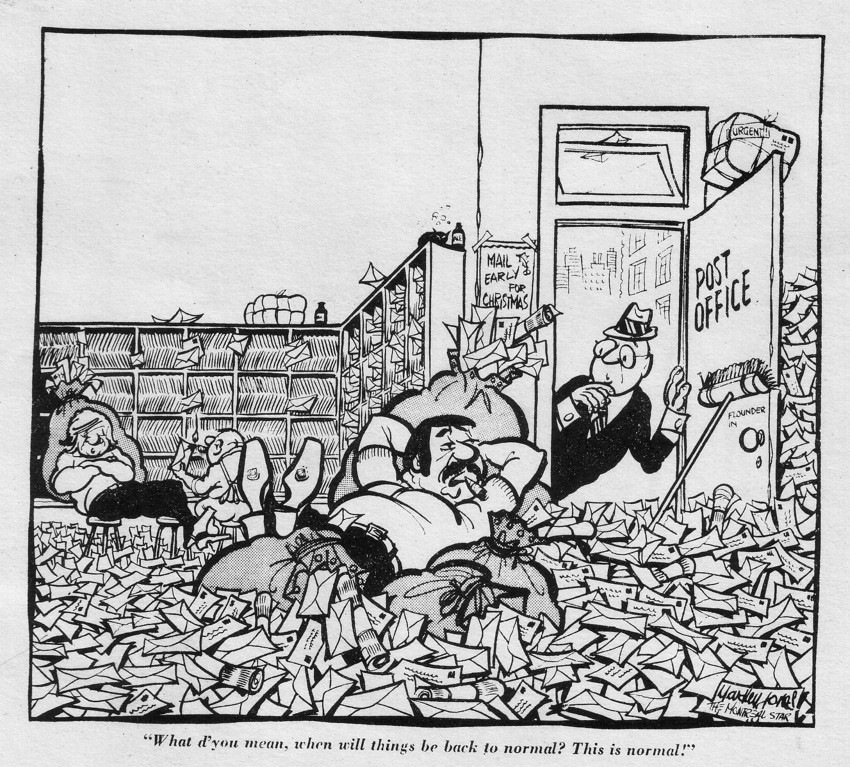

A WORD BEFORE YOU BEGIN...

This booklet was written by a worker who spent 9 months this past year at the Toronto Post Office. Like most workers on his shift, he is young (25) and single. And like them, he hated work – and so they fought back together. In some ways, therefore, this booklet represents more than just how one individual was affected by work and how he fought against it. The ways he chose to fight work were basically the ones chosen by the rest of his workmates.

When a couple of copies of this booklet were passed around the post office, most people said they liked it. Specifically they said it was good to see down in print what they thought and felt to be true about work. Discovering that other people basically see things the same way is especially important in this system, where "our needs come out last every time".

* * * * * * * *

Hail, hail, the mail's in there,
3
What the hell do we care,
What the hell do we care.
-sung by postal workers
during the April strike.

I really didn't like working at the post office. In fact, I hated it. After 9 months of working there, that is the only conclusion. Oh, the money was o.k., and I certainly liked some of the other workers, but when all is said and done, I hated work. And it wasn't simply the job itself, although sticking letters in pigeon holes isn't exactly the most fulfilling way to spend 8 hours a day. Much more than this, I hated work because of the kind of life it forced me to live 24 hours a day. Because, after a while, it became pretty clear that work affected just about everything I did away from work.

The shift I worked took my time from 9:45 p.m. to 6:15 a.m. So every night, some time before 9:45, along with about 400 other people, I would stop whatever I was doing and set out for work. Luckily, I lived close to work, so I could delay leaving until about 9:23. Some of my friends weren't so lucky – one even had to leave by 8 o'clock. But whatever time we left, they never started paying us until 9:45 or when we punched in – whichever was later.

Punching-in was probably the worst time of the day. Pushing down the card, waiting for the thud of the stamp to signal the beginning of another shift. It was just like entering a prison – at least that's how everybody looked. After seeing a friend drag herself up the stairs to our work area, I asked what was wrong. She simply said: "It's not 6:15 yet."

A couple of times, however, I managed to punch-in late – and get away with it! The best time I pulled this off was with another friend. We were both late, and while walking from the subway to the post office we agreed that a jammed subway door had caused our lateness. And figuring that a 15 minute breakdown sounded better than a 2 minute one, we took our time. In fact, we took our first "unofficial" break of the evening. After a cigarette and a good rap, we went upstairs to get the shift supervisor to sign our punch cards, went back downstairs to the card racks, went upstairs again to the work area and then began to work. All in all we gained about 25 minutes at full pay.

Even when we punched-in on time we would always go to a break area – either a washroom or a smoking area. At 9:45 some people would leave for the work area – in order to find stools. Most of us stayed, however, until about 9:47, when a supervisor would come out to tell us for the first time that evening that "we were paid to work". After some verbal opposition, we'd wander out into the work area looking for stools.

And there were never enough to go around. It used to piss me off that although they could spend millions of dollars on the new postal machines, they wouldn't buy the extra couple of dozen stools we needed. So I always made sure there were never any unused stools anywhere on the floor. Criss-crossing the floor looking for a stool, I made good use of the time by talking to friends.

The work itself was totally mechanical. We'd sit, or stand, in front of a sorting case that contained about 80 pigeon holes. (Officially called "cases", we often referred to them as "cages".) It would take about 3 or 4 shifts to learn a case. After that, sorting required no thinking, just reflexes. I remember Johnny Bower, who used to be goal tender for the Toronto Maple Leafs, saying that after practice the stopping of a hockey puck became a reflex action, that the nerve impulse from his eye, without going to his brain, would cause his hand to move. Sorting mail was exactly the same: I'd scan the envelope for the street name, house number, and town, then move my hand to the appropriate pigeon hole.

This operation was repeated over and over: 25 times a minute, 1500 times an hour. Over and over, for 8 hours each night. When I applied for the job, they made me write both a memory test and an intelligence test. But in no way did the job require any skill, beyond a basic ability to read. The part-time sorters, who did the same job, weren't required to write either test and, in fact, some workers who had failed these tests were allowed to work while waiting to take them again. The whole exercise was a holdover from the time when sorting mail required a detailed knowledge of the postal system, and nobody seemed to believe in it any more. Another reason they bypassed this selection mechanism was that they had to – with turnover rates above 50%, they needed any workers they could get.

No thinking; just reflexes. It's often said that sorting mail is boring, but that bit of understatement just doesn't come at all close to describing the true situation. In the first place, I learned to forget what I was doing, as I was doing it. Given the speed we were supposed to work, I never really had time to read the address. Rather I would run my eyes over the address looking for certain key words (like Toronto), certain key letters (the primary sort consisted in breaking down the mail alphabetically according to street name) and certain street numbers. After seeing these key sections of the address, I would deal the letter to the appropriate pigeon hole. By that time I would have forgotten the address. This "forgetting" was necessary because it took time for the next address and I found it easier if my mind was blank. And besides, who wants to remember 1500 anonymous addresses an hour? And so I learned to forget what I was reading. At the beginning I reacted to this by checking the case to see how I'd done – after a while I just didn't bother.

You could always daydream. In fact you find it necessary. Women, music, politics, time after work, all floated through my mind. Of course these images were totally unrelated to the actual work I was doing; I found myself working, and at the same time thinking, wishing, pretending I was somewhere else. Dope obviously helped. Like most large factories, lots of people were stoned or drunk much of the time. Hating work, wishing you were somewhere else, and yet finding yourself there each night....

Occasionally we would think about work. Or rather about how much better work could be. We all had our own ideas, and mine consisted of abolishing afternoon and night work (we can all afford to get our mail a day later); getting rid of all the bills (which nobody can afford anyway); and increasing our wages so we could afford to work a lot fewer hours. Besides, as a friend said: "With more time off, you'd spend more money."

When I was working at the "standard" rate of 25 letters a minute, my hand would always be moving. But if I got too absorbed in my daydreams, then my hand would stop. And as my hand stopped, my productivity would start to go down. For the supervisors, this was a real problem. Their job was to keep us working every minute, and as there was no official form of work measurement, they were reduced to watching our hands move. Any pause or hesitation, if spotted, usually invoked their second favourite saying: "Keep your hands moving."

There used to be a system of work measurement, but several years ago postal workers got together and had it abolished. Actually during the time I worked there they began a series of case checks which consisted of counting all the letters somebody had sorted in the preceding hour. But several grievances, some talking back, and widespread support for workers who had their cases counted, soon put an end to these checks.

Because they used our hand motion as a productivity counter, they kept a constant eye on all of us. In order to make this task easier, they had arranged the cases in long rows. Often they would simply stand at the end of the aisle – watching. And even when we couldn't see a supervisor, we could never tell when one of them would stick his head around the corner of the row. It was just like being kept under guard for 8 hours a day. And their system of "spy windows" only added to the prison-like atmosphere. Arranged so they covered the entire work area, these very narrow slits supposedly helped them stop some of us from supplementing our wages by sampling the cash, credit cards, dope, etc. that the mails carried. (In the new postal plants, they plan to use the "wonders of technology" by installing remote-controlled TV cameras.) The fascist-like atmosphere didn't go unnoticed – particularly the night the shift supervisor made the mistake of wearing a brown shirt.

The feeling of being spied on was particularly strong during the 6 month probationary period. First, the union, by officially refusing to stand by the probationary worker, eliminated the legal defense procedure. Secondly, because, when I started, I knew only one person casually, I knew I couldn't expect much support from a bunch of people I hardly knew and who hardly knew me. For both these reasons, the power of the supervisors loomed large and as a result I felt very vulnerable. And the 2 and 4 month efficiency (or progress) reports seemed to be used mainly as scare tactics. After a while, of course, as I got to know some of the other workers, I began to see how little real control the supervisors could actually exercise.

Nevertheless they did have some power. One thing they seemed to especially enjoy was splitting up friends. Because when people talked to each other they couldn't be forced to work as hard, they would constantly move us around. Obviously this made it more difficult to establish friendships, but this didn't seem to bother them – I think they would have been happier if we had all been robots. So they moved us around, here and there, as they pleased. Sometimes when they were directing us towards unused cases, they looked just like traffic cops, or parking lot attendants, or prison guards.

Our official breaks were also just as regimented. As in high school, they used bells to start and end these breaks. Unlike in high school, however, the bells weren't hooked up to a master clock, but were activated by a supervisor downstairs. The approach of break time caused a great deal of clock watching – all designed to prevent us from losing any break time. In fact, we would often stop working early and begin to make our way towards the cafeteria. This, of course, was discouraged by the supervisors, but they found it next to impossible to stop us from leaving our cases before the bell rang.

In part our leaving early was necessary because the 10 minute break hardly gave us enough time –considering the line-ups that formed in the cafeteria, which itself was located on another floor. Not that the food was good or anything. After eating their dinners for several months I found myself suddenly feeling very full just before lunch time. Overcooked vegetables, stale bread, dried out meat: after eating at the post office, McDonald's hamburgers actually began to look good!

Along with the poor food went the noise. Uncovered cement and brick walls don't absorb much sound, so we were treated to the noise of colliding dishes, voices, shifting chairs, etc. – and their echoes. I guess they figured covering the walls with a sound absorber would have been a poor way to spend money. They had painted the walls with large brightly coloured designs, presumably to "brighten" the place up, but it just made the walls look gaudy, which only added to the glare.

"The Post Office, as well as 'looking like a prison, also resembled a battlefield. Each night was filled with incidents, actions, and reactions, all designed to gain an advantage. For us, the aim was more money for less work: the supervisors and management obviously had the opposite goal."

But in comparison to the tension, caused by the supervisors' constant surveillance, the cafeteria certainly came out ahead, the food and noise notwithstanding. At least during the breaks and over lunch I could relax a little, talk with my friends, play cards and maybe do a bit of reading. Some workers used the lunch break to leave the building. They'd go to the closest all-night restaurant. The food was better, and just the fact of leaving the building gave a sense of relief. But half an hour isn't very long – even if you stayed inside. Of course they didn't pay us for our lunch break. The fact that all of us were there only because of the work – and if we had a choice we would have been elsewhere – just didn't count for them. It was just the same as the time we spent travelling to and from work: for us it was a necessary part of the job; for them, because it was "after hours", it was considered "free time", and therefore unpaid. The end of break times was announced by yet another ringing of the bells. Because we had to punch-in after lunch, we left the cafeteria on time, although even then some supervisors would loudly remind us it was time to leave – as if we needed reminding!

At the end of the break times, however, hardly anybody left on time. The bell would ring and we would just continue to sit there. The supervisors would begin yelling: "Let's go! Time's up!" But usually even this had only a limited effect. Considering what was waiting for us downstairs, it was a real effort for any of us to go back at all. And so the supervisors would walk over to the tables and begin to challenge us directly. More often than not, there would be some talking back, often in the form of belittling the supervisor personally. During the whole time I worked there, this scene was repeated every shift. Nobody ever had it together enough to refuse outright, but we all figured that if they wanted us to work, then they were going to have to work for it.

After break, while going back to work, our main concern was the length of time till the next break – and after the last break, there were only one and three-quarters hours till we finished. Actually we would only work for about an hour and 15 minutes, but we still had an hour and three-quarters until we could punch out.

During the winter months the night continued right past the time to punch-out. But when summer came, the sun rose shortly before the shift ended. I always looked forward to this event, hoping for one of those spectacular sunrises that often herald the coming day. The view itself wasn't that exciting – train yards, parking lots, expressways – but I always enjoyed seeing the light of day for the first time in 8 hours. But perhaps it was just because it announced the end of the shift.

Punching-out was the best time of the day. Impatiently, we would wait in line until 6:15. Then we would surge past the punch clock, half running down the stairs, getting our coats from the lockers, stepping outside: FREE. Another night done – another night gone. At 6:17 the morning rush hour hadn't started. So walking home along the almost deserted streets I relaxed for the first time since the shift had started. With the calm of the city providing a much needed relief from the tension of constant surveillance, from the pressure of forced work, I would try not to think about having to go back to work that evening.

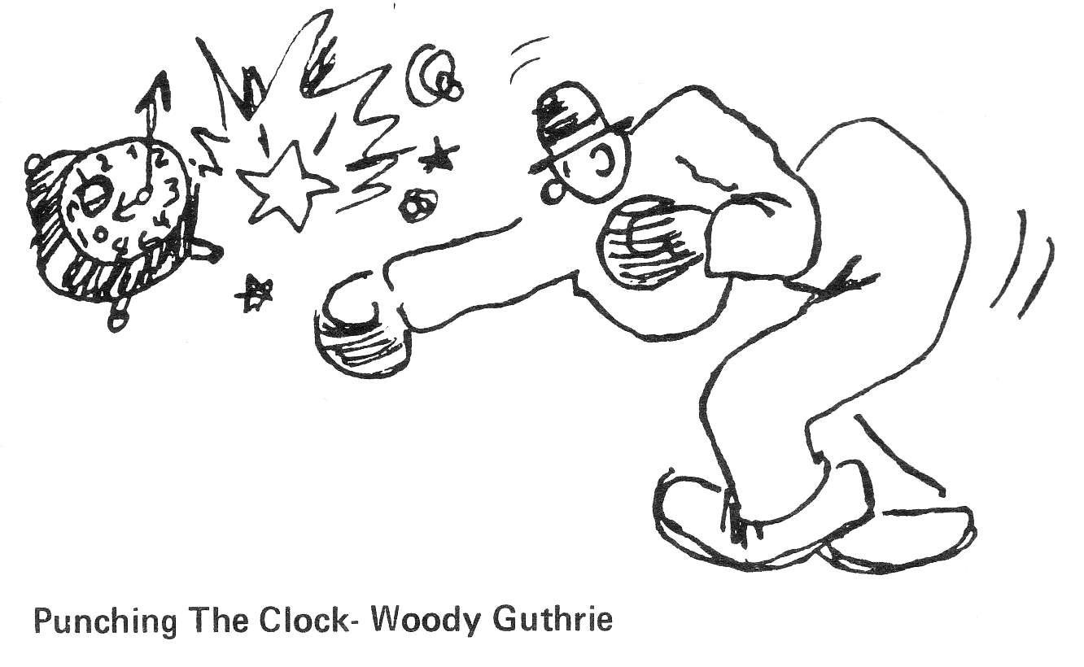
But no matter how hard I tried, I could never really escape. Already the travelling time demanded by work took away some of my free time. Because I lived close to work, it only added about an hour to my work day; for other people, it added up to three hours a day. And if I was going to function even moderately well at work that night, I obviously had to get some sleep, eat some food, make sure I had some clean clothes, etc.

Not that I would have stopped sleeping and eating if I had stopped working, but in that case I would do these things to renew my energy for my own activities instead of for work. Work also determined when I could eat and sleep – one of the greatest benefits of quitting was regaining the possibility of sleeping at night. So laundry, food, sleep, shopping, errands, all conspired to take away most of my free time. Even before I reached home, my day, which on leaving work had stretched so invitingly before me, began to disappear behind the time taken by those chores required just to keep me going.

As a result, my time became very precious. Already a clock-watcher at work, now, in a vain attempt to preserve my free time, I began to clock-watch at home. At work, where the clocks told me how long until I could leave, they never seemed to move fast enough; at home, where they ticked away the time until I reentered the factory, they moved at a speed which more than made up for their lethargy at work. To gain more free time I cut down on my sleep. I slept only 5 or 6 hours a day, but it really didn't make that much difference. There was never enough time. And even when I had gained some free time, my head, knowing that in a few short hours I had to go back , was never free. Long before I was ready, it would be time to go back to work.

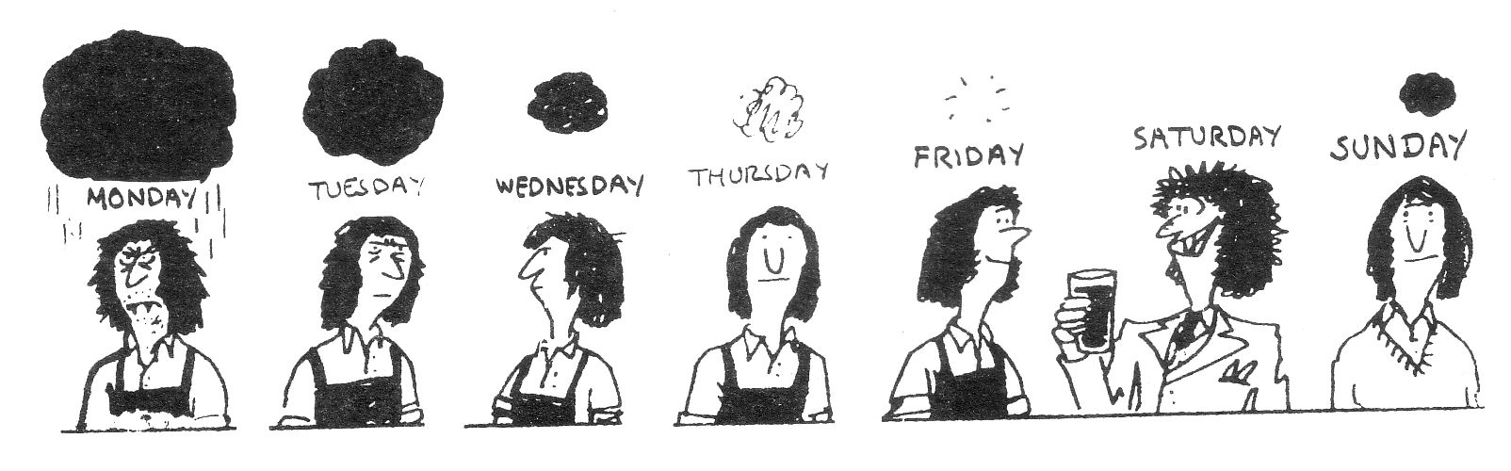
And work didn't just steal my time. It also sabotaged my friendships. If friendships are to grow and develop, they require time – and work certainly left very little of that. Second because most of my friends (and most people in general) worked days and I worked nights, I found myself "out of step". My friends, after working during the day, would spend the time after dinner relaxing; I would spend the same time trying to "psych" myself up for work. In the morning, when I had finished work, they would either be sleeping, or rushing off to work. Sleeping when most people were up and about; working when most people were sleeping; losing any semblance of "night life": work pressed my life into a topsy-turvy world.

My relationships with women also suffered. First of all, work prohibited me from making love at night. Before I started working at the post office, that had seemed perfectly normal. Now, under the "rules of work", it was forbidden. And if I took time off to satisfy my needs, then they would impose penalties in the form of suspensions and ultimately firing. Even being able to relax with women was, for most nights, completely out of the question – even though half my shift was made up of women. With all the pressure of management's "spy-system", everybody was on edge. So it was difficult to feel at ease and, as a result, it was hard to get to know each other. This obviously affected my relationships with men as well, but somehow it seemed to interfere more with my relationships with women.

The "guys downstairs" in the Traffic department were forced to spend most of their evenings and nights without even seeing a woman. This certainly made it more difficult for them to feel at ease with women after work. Towards my girlfriend I became much more demanding. Feeling the pressure and tension of work, I put pressure on her. Not only did my sexual needs come first, but it was my problems and my feelings which received the most attention. For her, I gave less support. My friends have said that work affected them in much the same way. Considering how segregated most workplaces are, it's not surprising that relationships between men and women are so messed up.

Evenings were the worst time, because then work imposed its timetable most ruthlessly. Along with a number of friends, I used to go to a pub about once a week. We'd go about 9 and stay till closing. In fact it became a bit of a social institution. But work put an end to all that, and so, as they would wander off to the pub, I'd go off to punch-in. Over a period of time, unable to keep contact, I found myself getting more and more isolated.

Work undermined my friendships in yet another way. An integral part of most relationships is having common experiences, doing things together. But most of my friends didn't work at the post office. That's the way things are organized in this society. When you apply for a job, you do it alone, as an individual, not with a group of your friends. Work probably took more time than anything else, and it certainly was my most depressing activity. But because my friends didn't share my work experience, the amount' of support I could get from them was obviously reduced. On the other side of the coin, dominated by work, taken up by events there, I was less able to provide support for them.

Shortly after I started working at the post office, a friend there told a supervisor to "Fuck off!" Needless to say, this was quite an event. Even after he quit, we would refer to him as "the guy who told Harvey (the supervisor) to fuck off." And knowing Harvey, we all thought it was really right-on – the only problem being that he got disciplined. (I think he put his disciplinary letter up in his bathroom.) But for my friends outside work, caught up by the pressure of their own work, this incident just didn't mean that much.

"Occasionally we would think about work. Or rather how much better work could be. We all had our own ideas, and mine consisted of abolishing afternoon and night work (we can all afford to get our mail a day later); getting rid of a72 the bills (which nobody can afford anyway); and increasing our wages so we could afford to work a lot fewer hours."

Over a period of time, the lack of time, the opposite schedules, and the different experiences, all combined to force us apart. I found my circle of friends reduced. Whereas I had been regularly spending time with about a dozen people, work cut this number down to 2 or 3. My work-friends had the same experience. For all of them, work meant spending less time with their friends.

Even when I slept, work would pursue me. After working about 2 months, I had my first dream about the post office. I was sitting in front of a case trying to sort the mail. But every time I moved my hand towards the right pigeon-hole, the letter would just drift away. So I'd try again – and get the same result. Over and over I tried, never managing to put a letter in the case but at the same time, for some reason, I couldn't stop either. Finally I woke up. Everybody at work, at least everybody I talked to, had also dreamed about the post office. The dreams were all different, but two themes seemed to run through them all. First, we couldn't sort properly, and second, we had to keep trying. Although we always called them "dreams", they were really nightmares, but I guess it was just too heavy to admit that work gave us nightmares.

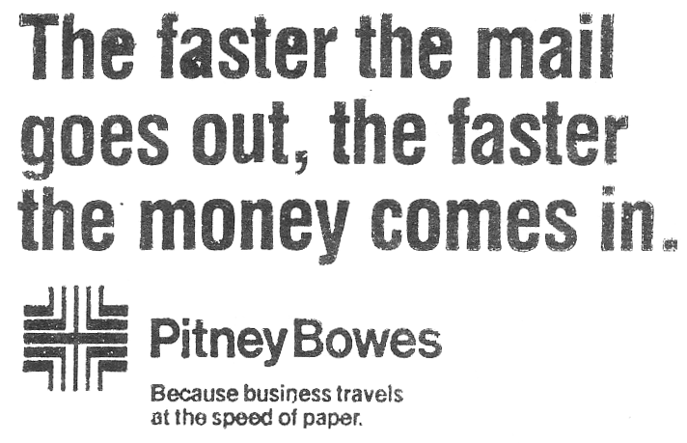
I remember talking with a number of work friends about work and the effect it was having on us. We all agreed it was making us irritable, was cutting us off from our friends, was dulling both our senses and our minds, and was attacking our self-confidence (After all, being forced to do something you hate and you know is a waste of time doesn't exactly improve your belief in your ability to handle the situation). But all these problems seemed to us to be simply the result of the way this society has organized our whole life around work. Both on and off the job, we are subject to a system of rules and regulations which seem designed to distort our lives – at least that is the major effect is has on us. In fact, all the institutions of this society – schools, family, government training programs, and so on – seem designed to make us ready, able and willing workers.

"If they had been willing to spend a bit more money, then work would have been quite different. We worked nights because: a) big business and government saved money by having next day delivery: b) government saved money by having two shifts use the same equipment and facilities. In comparison to what working nights does to your life, the extra money involved in: a) getting the mail out a day later; b) buying more equipment and more space, would have been more than well spent."

On the job itself, the supervisors weren't the major problem – or rather, they were the problem only to the extent that they insisted on enforcing the rules. Like most places, there were "good" and "bad" supervisors, and the difference between them was exactly how much they pushed us, how much they believed in this system of work. Management always claimed that this was the most efficient way to organize work, but we all knew it wasn't very efficient for us.

Of course we only worked for the money, but with inflation and everything, the next pay-day seemed to come around just in time. To get ahead, to save up any money was next to impossible. So most of us were forced to work – we had no choice. With taxes, rents, food prices, etc. eating up our hard-earned money, we were inevitably forced back to work. And we all agreed that we couldn't possibly buy enough to come close to making up for the life work forced us to live. In fact, no matter how much they paid us, we didn't think it could ever really be enough. After all, money doesn't buy back lost time. Writing about a hundred years ago in London, Karl Marx said that in capitalist society workers exchanged their creative power, their ability to live, for the money necessary just to survive, just to get them back to work. I think he hit the nail right on the head.

None of us, if we could do anything about it, planned to spend the rest of our lives at the post office. During the time I was there, several people retired. After spending 15, 20, 30 years of their lives working nights, they were finally leaving. We always stopped work and had a small ceremony. They'd get a small present from management and maybe a bit of money – and a lot of thanks. It just wasn't worth it. It wasn't, as they say, the way I was going to spend my life.

So I quit. And I wasn't alone; people were leaving all the time. When I started, the turnover rate was about 50% a year, that is, half the people who had started in the last year had quit. By the time I left, the pace had picked up considerably. People who had worked there for several years were saying that more people were leaving than ever before. One supervisor even said that the turnover rate had reached 80%!

For management, the high turnover was a real problem. (It seems that almost everything we enjoyed doing, they considered to be a problem.) They didn't like our leaving for two reasons. First, it meant they couldn't be very selective and had to hire just about anybody who came along. Second, because we were leaving anyway, the threat of firing lost a lot of its force. For both reasons they found it difficult to make us work hard. And we certainly weren't into helping them!

For if I quit work because I refused to live the kind of life it forced on me, then I also refused, as best I could, to live that life even while I was working. Every night I worked was a night lost forever. If they were to try to take my life away from me, then they weren't going to get away with it without a fight that would cost them as much as possible.

"My relationships with women also suffered.... Work prohibited me from making love at night. Before I started working at the post office, that seemed perfectly normal. Now, under the "rules of work", it was forbidden."

Because they were fooling around with my life, I felt more strongly about this than practically anything else. All the more so because if they had been willing to spend a bit more money, then it would have been quite different. (For example, we worked nights because: a) big business and government saved money by having next day delivery; b) the government saved money by having two shifts use the same equipment and facilities. In comparison to what working nights does to your life, the extra money involved in: a) getting the mail out a day later; and b) buying an extra several hundred cases and more space, would have been more than well spent. Interestingly enough, when the new postal plants are opened up, they plan to increase the number of people working afternoons and nights.)

We all seemed to think the same way. Certainly we all spent a great deal of time getting back as much as we could. Oh, there was the occasional person who was into working – like the unskilled guy who was about 40 and had 9 kids – but they were just overwhelmingly outnumbered by the rest of us. The only time I ever heard the work "liberated" was in this connection. One guy, who had really been into working when he started three years ago, had over that time come to the conclusion that working hard just wouldn't get him anywhere. And so he decided to just relax, take as much time as he could, and enjoy it. In comparison to how he felt before, he said that now he felt "liberated". Obviously he wasn't really liberated as long as he was forced to work at all, but when I left, he was planning to do something about that. In this whole process, he was strongly supported by his work friends. In fact, our struggles against work were one of the few things about work which gained our enthusiasm. And this feeling was tempered only by our concern not to overstep the limits of our power.

Most relationships at work were based simply on the fact we all worked at the same place. As you got to know people better, you found that you had other things in common, but for a long time work was the major reference point. This was especially true at the post office because, with the high turnover rates, people were leaving all the time. In most ways, however, working didn't provide a very good basis for relationships. First, because we exercised so little control while working, very little of us "came through". After all, robots don't have much of a personality. Second, people are more attractive, more interesting when they're doing something they enjoy – and none of us enjoyed working.

Laundry, food, sleep, shopping, errands, all conspired to take away most of my free time. Even before I reached home, my day, which on leaving work stretched so invitingly before me, began to disappear behind the time taken by those chores required just to keep me going."

In contrast, our struggles against work provided a much better basis for relationships. First, because they were enjoyable – certainly they beat working – there was a certain enthusiasm. Second, because we had to do it ourselves – no"representative" (for example, the union) could do it for us – through them we could exercise some control over ourselves. Third, because all of us were engaged to some extent, there was a real feeling of being together against management. Caught as we were in a system where our needs came out last every time, our struggle against work was the one way we could "be ourselves", could act on our needs, could affirm our presence and importance. Thus taking a night off, taking "unofficial" breaks, talking back, refusing orders, etc. all generated enthusiasm, pleasure and support. Hating work, and feeling the need to fight back, I found this support, expressed in both actions and words, to be the best thing in the whole post office.

And it certainly wasn't just limited to the men. Because women made up about half my shift, it was clear that if they weren't in favour of something, then it just didn't happen. But they were certainly into the struggle against work. After being without a woman supervisor for several months, management found it necessary to appoint one. After all, the male supervisors couldn't cover the women's washrooms very well!

I think it was the equal participation by women in the struggle against work which accounted for the degree of equality in relationships between men and women on my shift. Of course in many ways the men did, have more power, but compared to other places I've worked, the women put up with a lot fewer hassles. In fact comments about a woman's body usually invoked a very cold, "Fuck off, buddy". There were a number of reasons for the power of the women: they received equal pay; they did (and didn't do) the same work; they made up half the shift. And then there's the existence of the women's movement. But after all these, still the most basic reason for the degree of equality between men and women was our equal participation in the struggle against work.

One of the more effective ways we fought against their system of work was by taking a night off when we wanted to. Even now I can vividly remember the pleasure, the sense of relief that followed my calling in sick. With that phone call I would have gained a free evening. We used this time to do different things. Sometimes it would be a rock concert or a movie, other times it would just to be with friends or to sleep. But all these activities had one thing in common: we felt they were more important than working.

On returning to work after being absent, we had to get our punch-cards from the office. During the summer, because so many of us decided to enjoy the evenings outside, there would always be a line-up outside the office just before 9:45. Coming to work it was nice to see that other people were taking time off too. According to the contract, we would get paid for 15 sick days a year (8 with a doctor's note; 7 without one). And so we were a very sickly lot. Practically every night one or another of my work-friends would be absent. My guess is that absenteeism ran somewhere around 10% a night, although on one Friday night about two-thirds of my shift just didn't bother to show up.

Another way we could take time off and get paid for it was called "court leave". This meant that we would get paid if: a) we were on jury duty; or b) if we produced proof that we had been in court with the purpose of testifying. Since we didn't actually have to testify, it was possible to go to court with a friend and then get the court clerk to state that you had been an "uncalled witness". As one person said: "It's a choice between 3 or 4 hours in court and 8 ½ hours at work."

In another department, the people went about taking time off with pay in a more organized way. Thirty minutes before the end of their shift, about half the people would just leave! Of course they couldn't just stride out the front door, but they had discovered many "escape" routes which led from the work areas to the outside. As one of them said: "We're only paid to be here for 8 hours, so there is no way I'm going to stay a minute longer." Many workers took turns staying back to punch the cards of the ones who left early. In the same department, people also made a practice of getting sick just past the 6 ½ hour mark of their shift. The contract says we would get paid for the full 8 hours if we punched out sick after 6 ½ hours – without losing any of the 15 days paid sick time. So regularly these workers got their travelling time paid for – and then some. On my shift, this tactic wasn't as interesting, because not much is happening at 4:15 a.m.

The list of ways to take time off and still get paid for it is endless, just one more example. By taking time off during the week and then working a day's overtime, you could get paid for 44 hours while actually working 40 hours! In this case, you get paid more for working the same hours, but since we wanted to work as little as possible and get paid as much as possible, it works out to be better for us.

Most of the time, however, the struggle against work was actually conducted right on the shop floor. Long before I started working at the post office, workers had set up a system of "unofficial" breaks. Not recognized in the contract, their establishment and maintenance depended entirely on the relative power of the workers and the supervisors. During the time I worked there, there was an uneasy balance of about 10 minutes an hour in force. Often of course we would take longer, but 10 minutes usually didn't provoke any hassles from the supervisors.

Originally these breaks had been taken in the washrooms, but since this is a difficult place to police, management had set up a special smoking room. And we often used to take our breaks in the stairwells. Any place, in fact, where we could get away from the watchful eyes of the supervisors was used as a break area.

We often used to take breaks together, using the time to talk with our friends. The supervisors didn't like the idea of us taking breaks together. They lectured us several times, saying it looked bad if a lot of cases were vacant at the same time; we thought they were upset because it was harder for them to hassle somebody if they were in a group. They used to time us as well. On leaving the work area we would often notice a supervisor glancing down at his watch. And if you were particularly tardy, or if he didn't like you for some reason or other, he would come around afterwards just to hassle you.

They also used to raid the washrooms and smoking areas all the time. These raids would provide the occasion for often heated exchanges. Most of us claimed we had just arrived, while they would insist that we had taken enough time. One guy was particularly good at needling the supervisors. As a supervisor came over to tell us to go back, he would say in a loud voice: "Oh look, our waiter's coming! I'd like a steak, medium rare, of course...." Sometimes the supervisors would turn red and just walk away! Usually, however, they would try to ignore these comments and tell us to GET OUT.

Sitting outside the washroom provided an excellent view. First the supervisor would disappear into the washroom only to re-appear a few minutes later, tight-lipped and wearing a scowl. After a suitable interval, he would be followed by up to 20 people who would be laughing and joking with one another. Then in another minute or so, more people in one's and two's would begin to drift back into the washroom. In some ways it was just like a battle for control of the washroom.

One time, because a supervisor had ready hassled a worker, we decided to have a shit-in. Although it was poorly organized, about 35 of us ended up just standing around waiting for the stalls to open up. The supervisors came, and after some talking back and forth some people went back. The rest of us just stayed there until we had finished our business.

Even when we were sorting, we would often refuse to go along with their plan. Talking and stopping work as much as we could was only one way. Another was missorting. Usually this was not done deliberately – it was just a lot easier than being careful. But sometimes – especially during the slowdown which was organized to defend a shop steward who had been fired – missorting was quite deliberate. And apparently workers in other post offices were into the same thing. I remember getting a series of letters destined for France that had been mailed in Boston! Dutifully I sorted them on – after adding "via Toronto" to the address.

"Of course they didn't pay us for our lunch break. The fact that all of us were there only because of the work – and if we had a choice we would have been elsewhere – just didn't count for them. It was just the same as the time we spent travelling to and from work: for us, it was a necessary part of the job; for them, because it was "after hours", it was considered "free time" and therefore unpaid."

For some workers, including some who took an active part, the amount of "dogging it" was a cause of concern. While often enjoying their unofficial breaks, they would decry the lack of enthusiasm displayed towards work and warn that "if people didn't start working harder, then the whole system was in trouble." While this is true, I think their warnings were more rooted in their fear of provoking a crackdown by the supervisors. Certainly through their actions, since they stopped work about as much as the rest of us, they demonstrated little concern for the "system".

Every night all of us used most of these tactics. So much so, that as well as looking like a prison, the post office also resembled a battlefield. Each night was filled with incidents, actions, and reactions, all designed to gain an advantage. For us, the aim was more money for less work; the supervisors and management obviously had the opposite goal. And over the years we've had some success.

Speaking to the Vancouver Board of Trade in April 1972, the Postmaster General said:

"It is surprising to note that since our employees have been provided with better working conditions and higher salaries, since 1965 to be exact, the productivity index at the Post Office has fallen by 12.5%.... To compensate for this drop in productivity, we had to hire more people; this represents an additional expenditure of nearly $17 million. Obviously, this state of affairs cannot continue. It would be totally illogical to think that the Post Office will continue to absorb the cost of this loss of productivity, inflating its deficit by taking on employees who, under normal circumstances, would not be needed."

In short, the post office is faced with workers who are working less and getting paid more. Significantly, the introduction of the new postal system is designed to "correct" this situation by making postal workers work harder and by reducing their wage levels. But it seems to me that the workers will be able to deal with this, just as they have pretty successfully dealt with all of management's ploys over the past few years.

But regardless of such far-reaching implications, for the most part our struggles were buried inside the post office, far from the public eye. To be sure, postal workers are not generally considered to be the hardest-working of workers, but with most of the mail moving reasonably quickly, little thought is given to the situation of the people who move the mail. All this changes when postal workers stop work altogether in a strike.

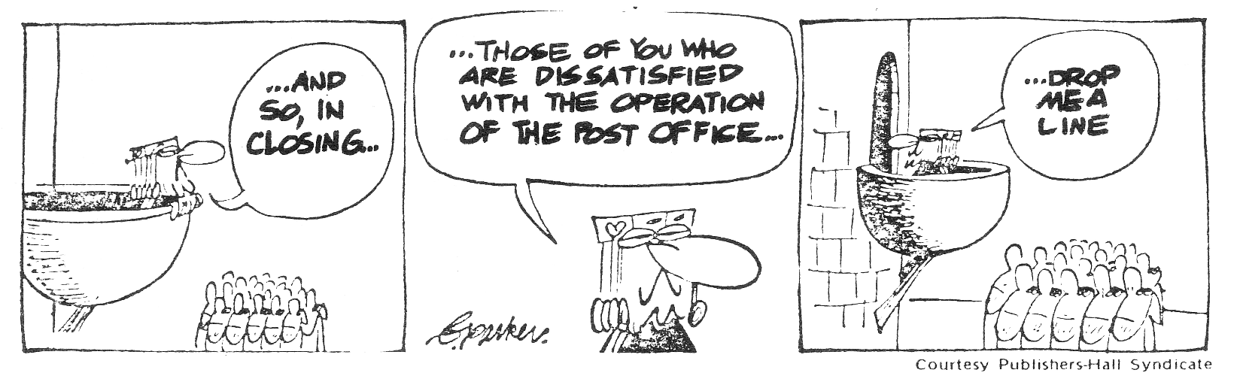

During the 9 months I worked there we had 2 strikes. Both times front page articles recorded the strike events. Editorials, noting the personal and particularly the financial inconvenience, made ringing statements about "essential services" and threats of "anarchy". And the TV news dutifully showed shots of piled mail bags and picket lines. In many ways though, these strikes were only a continuation of the daily struggle against work. Certainly the constant tension between needing the money and hating the work was still present, and played a major role in determining how we viewed strikes.

"In another department, the people went about taking time off with pay in a more organized way. Thirty minutes before the end of their shift, about half the people would just leave.... As one of them said, "We're only paid to be here for 8 hours, so there is no way I'm going to stay a minute longer."

First, being on strike was like having a holiday. We could sleep at night, see our friends, and since we were all doing it together we didn't really have to worry about being disciplined. On returning to work after the 2 week strike in April, the question on everyone's lips was, "How was your holiday?" And even after we'd been back only a couple of hours, we were talking about the need for another "holiday" – soon.

On the other hand, being on strike meant losing money. None of us was happy about this, and with few exceptions, any desire to have the job reflected our need for money, not an interest in working. As one guy put it: "I don't care if this fucking place burns down; but I just started and I need the money to pay the rent." Both times I went on strike it was illegal, but this had little effect; after all, we'd broken the law before. No, the major consideration was whether we could pull it off, whether we could afford it.

In other ways, of course, being on strike was different. First, it was an escalation of our daily struggle because we were all acting together. On the shop floor, all of us took nights off, took breaks, etc., but we did it more as individuals, rather than in unison. In part this was because we were less visible and therefore less vulnerable when we didn't co-ordinate our actions too much; in part because each of us preferred to take different nights off, take breaks at different times, etc. Obviously these struggles had some effect, but during a strike, because we acted together, our effect was much greater. About 48% of all the mail in Canada passes through the main Toronto post office, so even a short work stoppage puts enormous pressure on management. My shift was solid during both strikes, and in part this accounts for the lack of disciplinary action taken against us.

Second, being on strike was different, because of the involvement of the union. On the shop floor, our struggles were conducted almost totally outside the union. Of course we would file grievances, but usually they were designed more to hassle management than actually to make any gains. For that, we relied on ourselves and each other.

During a strike, however, the presence of the union made itself felt. In part this was useful because, if the union officials supported a strike, then we were in a much stronger position. But the union's prominence during strikes was also a drawback in that they would try to run the show. In this respect they were sort of like supervisors who were always telling us what we would and couldn't do. The union officials preferred it when we just followed their orders, but since there was never any strike pay, their orders usually left us cold. Besides, the union's orders never amounted to much – the union officials by their actions made it all the more likely that we would simply take a "holiday" during a strike.

"If I quit work because I refused to live the kind of life it forced on me, then I also refused to live that life even while I was working. Every night I worked was a night lost forever. If they were going to try to take my life away from me, then they weren't going to get away with it without a fight that would cost them as much as possible."

When a strike was over, the situation would quickly return to normal: the newspaper headlines would change to other topics, the union would retreat into its offices and meetings, and on the shop floor the struggle against work would resume. Even on the first night back, fresh from the time-off, we would be taking breaks, talking back – just like before. If anything, the time off just made it that much harder to fit back in. And so day in and day out, right up until I quit, this struggle continued.

On my last night, after coming in late, I spent the time walking around saying goodbye to my friends, and just looking at the place where I'd spent so much time in the last 9 months. Even on the last night, I was hassled by the supervisors: "I know it's your last night, but you're being paid to work." Saying goodbye to my friends was the hardest part of leaving. Over the time I worked there I had gotten to know some people pretty well – we'd been through a lot and had fought back together on numerous occasions. And now, if my leaving was at all like that of others, I probably wouldn't see most of them again. Still the need to quit the post office was stronger. Walking down the ramp to the door for the last time, I could hardly believe the sense of relief I felt.

But at best, it's only a temporary reprieve. My next job will probably put me back in much the same kind of situation. And as long as even one of my friends is working at the post office, I'm still affected by it. A few weeks ago I went out drinking with a friend from the post office – he took the night off! Most of our discussion centered around work – or rather, around recent incidents in the struggle against work. And as we talked, it became very clear that neither of us would really be satisfied until we "never had to go back again – ever".

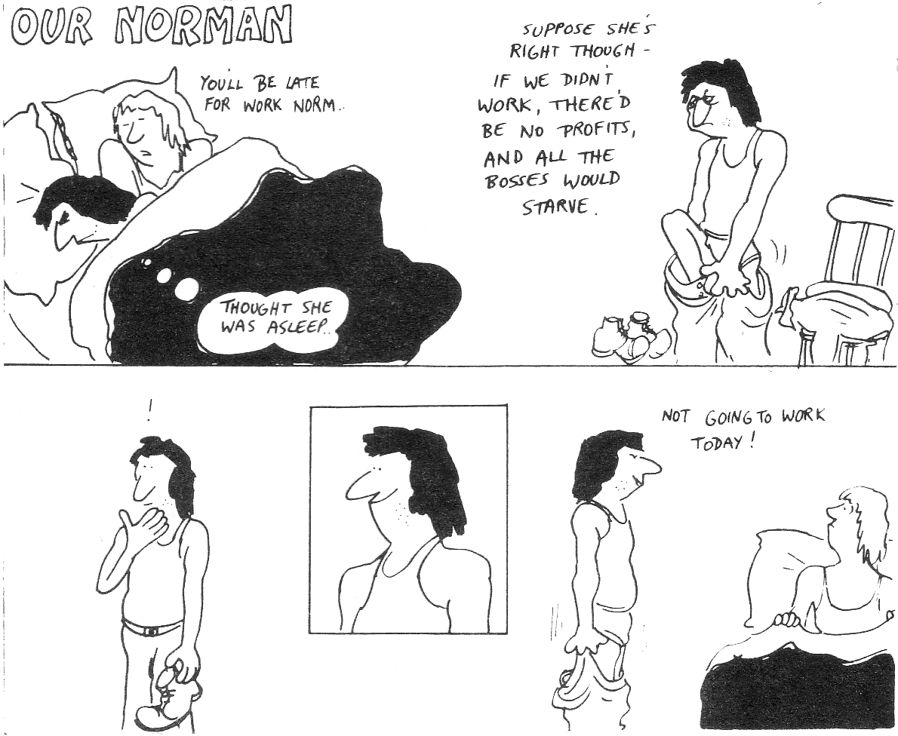
P.S.

This booklet concentrated on the situation of young, single workers. As such, it described in detail the ways they fight against work. For example, the writer's decision to end his "tour of duty" after 9 months has been done by so many other people that management is faced with a permanent shortage of workers. This, in turn, has enabled people who stay on the job to resist management's attempts to get them to work harder – they can't just go around firing people, because somebody has to be left to keep at least some of the mail moving, however slowly!

But if the young, single worker can resist in certain ways, it is clear that almost everybody at the post office also struggles against work – struggles for more money for less work. (Supervisors excepted, of course.) Workers on days, for example, are "masters at dogging it". Using their experience and their willingness to stick together in working less, they have managed to cut their work load by more than half over the years.

Taken together, the permanent slowdown by day workers and the upfront refusal to work by workers on afternoons and nights have given management quite a headache. And when you think that the struggle against work is going on in every post office in the country, it's no wonder Postmaster-General Mackasey is "concerned". The strength of all postal workers in the last few years – working less and getting more money – has forced the government to spend millions of dollars to introduce the new machines. As Mackasey told the Toronto Star: "We have to automate. We have to be able to handle increasing volumes of mail efficiently.... It is imperative the post office function."

For them, "efficiently" means to decrease wages by de-classifying most jobs and cutting back on the number of workers hired. It also means to get more work out of the people who stay or will be hired at the new plants – for example, by trying to make people work at the speed of the machines, like the coding machines, which have automatic timers. In other words, they plan to use the new postal system to get more work for less money.

Struggling against work is something postal workers have in common with each other. And it is also something they have in common with the rest of the working class. In practically every factory, office, school and home, people are working less and trying to get more money. Over the last few years, the big question in the business papers of North America and Europe is how to keep wage gains down, how to get workers to work harder, how to increase profits. In some ways, this is what they hope to accomplish through the ridiculously high rate of inflation. And workers are also increasing their struggle for more money for less work. In Canada, people have been stopping work to demand more money at a record rate. In 1975, more contracts come up than ever before. With inflation going even higher, it's likely things will heat up even more.

Unofficial walkout

Wilson is threatened by U.K. Ford strike

London (Reuters): About 1,800 determined and embittered strikers, who want more pay for their “boring and exhausting” jobs, yesterday threatened the heart of the ruling Labor Party’s election campaign.

The unofficial strike at Ford automobile plants near London and Liverpool has gone on for two weeks and could breach Labor’s much vaunted social contract – the Government’s voluntary wage restraint agreement with the unions designed to curb inflation.

Prime Minister Harold Wilson’s Labor Party was further ahead yesterday in the latest opinion poll predictions for the Oct. 10 election, but its opponents pointed to the strike as an example of weakness in the social contract.

The strike has put 15,000 men out of work and is costing Ford about $6 million a day in lost production.

Ford warned that there may be further layoffs, while the representatives of 6,000 more Ford workers voted to support the strike and put more pressure on union leaders, who are trying desperately to co-operate with the Labor Party.

Jack Jones, leader of the Transport and General Workers Union has asked the men to go back to work, but strike leader Arthur Flicker handed Mr. Wilson a leaflet as he entered Labor headquarters for his daily election press conference yesterday, saying the dispute was a long-standing one not meant to embarrass the Prime Minister.

Mr. Flicker appealed for understanding for men who have to do “repetitive, boring and exhausting” shift work which wrecks their social lives because of the awkward hours.

Ford has agreed to negotiate new wages for all its workers, even though the existing one-year agreement has five months to run and the social contract asks for wages settlements to last 12 months.

Toronto Globe & Mail, September 25, 1974.

