[Editor’s Note: This 1952 text is taken from the 1973 Bewick Editions reprint.]

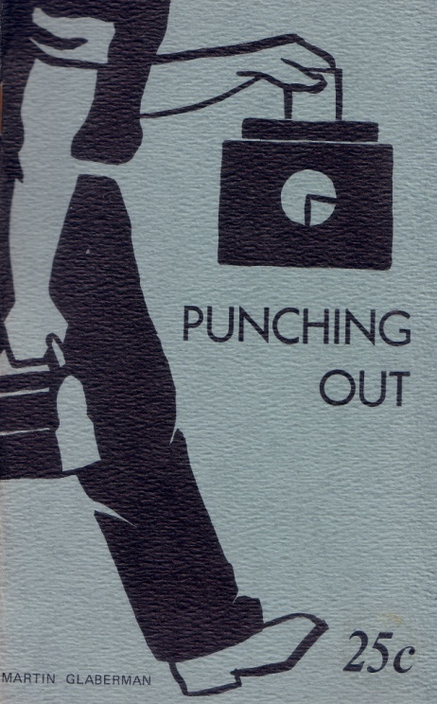

PUNCHING OUT
By
Martin Glaberman

Not long ago two men in a Detroit auto plant were discussing their steward. Both had known him for long years. They had worked together in the same department when the shop was unionized in 1937. None of them were very active in the union but all three were among the first to join.

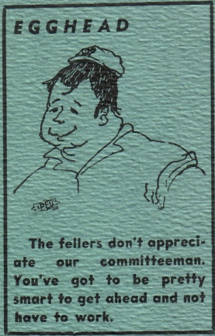
They had done picket duty together — in 1937 and again during the war when the plant had wildcatted a couple of times. They had helped organize an undercover terror campaign against a foreman that they finally threw out of the plant. One way or another each one was looked to and respected by the men around them. They were not foolhardy men. But they had courage and self-confidence, gained from long years in the shops. They were years spent in constant struggle over production; in cutting the ground from under a foreman to give the men greater freedom in arranging production to suit themselves; in isolating and defeating a steward who proved himself incompetent or a company man.

Only four months before they had put the new steward in to try to regain some of the ground lost by the union over the years. And now they were discussing their friend.

"Joe should know better," they agreed. "He's a worker just like us. And now he's just a contract lawyer like the rest of them."

What it all boiled down to was — Why?

Why does a working man or woman, chosen by his or her fellows to represent them, sooner or later turn against them? Why does a worker, when he is elected to union office, turn against his own kind? How does an ordinary rank and file worker become a pork-chopper, a pie-card, a bureaucrat?

The question isn't a personal one. At one time or another it has been asked in every shop, in every city in the country. In auto plants, in steel mills, in coal mines, on ships in every port, the same question keeps coming up. It is a fundamental question. It is one of the most important questions facing working people today.

YOU CAN'T HELP YOUR BUDDY

The general feeling in the shops today is that the men chosen by the workers to run their unions, to represent them against management, although chosen, by and large, from their own ranks, aren't worth a damn. From top to bottom the union is run by bureaucrats, by people who may once have been workers, but who are now a group apart, who oppose or ignore what the workers want to do.

What is it that the worker wants? You just have to look around you a little bit, listen for a while, and you'll get an answer. He wants anything but what he's got.
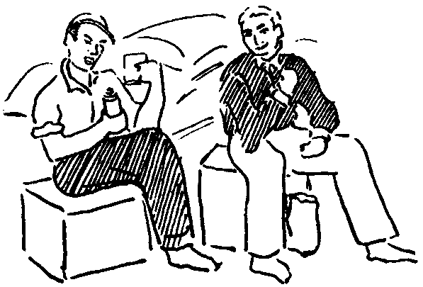
The idea that comes up as often, or oftener, than any other in talk in the shops is to get out of the shop. Everyone has heard it. Most of us have repeated it ourselves. Anything is better than working in a factory. A milk route, a small garage, a salesmen's job. It may pay less and the hours may be longer but it's a way of getting out of the factory. Every time there is a layoff, men say that if they can find any half-way decent job on the outside they won't be back.

But everyone knows that getting out of the shop is just a dream. They always come back. Once in a while a man saves his money carefully — and his kids' if they're working — and gets himself a small farm. Or someone finds another kind of job. Some of them make it but most are back in the shop after a year or two, building up their seniority from the bottom again.

What is meant by all this talk is that there has to be some kind of basic change, that working in a factory is a hell of a way to make a living. Everyone knows that getting out is next to impossible. The change must be inside the factory.

A man wants to grow. He comes into the shop with brains, ability, and the desire to learn, to develop himself. He is put on a machine, told what muscles to use, and forbidden to use any other skill or ability he may have. To add to his knowledge he has to figure out ways of getting around the shop rules and the union rules.

Workers Want To Learn

To work a job other than his own he must be sure the foreman isn't looking. To see how something is done in another part of the plant he has to sneak behind machines or piles of stock. The rules are almost always violated because no one can suppress the desire to learn, to see how things work. But workers want to be able to learn as human beings, not as criminals. They want knowledge, the power to learn, to be theirs as a matter of right, not as something that must be stolen from the company.

If a worker wants to learn, it is not for the sake of getting a lot of useless information. He wants to learn in order to be able to use his knowledge in the organization of production. Time after time workers get together to discuss the mistakes of supervision in planning the production process, the ignorance of foremen of what their machines will do. One of the deepest sources of resentment in the factories today is the fact that the workers' knowledge and ability in production must be kept secret from the company. Management attempts to get some of this information through suggestion plans in which rewards are offered for improving production. But these plans are usually boycotted by workers. They are profoundly convinced that any improvement in production today will only help capital and work to their own disadvantage.

Many times workers devise short cuts for doing their jobs, sometimes even tools or gadgets to ease the work. In some places these are kept hidden from supervision, even if it means taking them apart at the end of the shift. In other places there is an understanding that the foreman will not report such labor-saving devices to higher supervision.

In a zinc smelter in Pennsylvania, near Pittsburgh, a man was given a job which required pulling a series of switches that controlled the furnaces. He sat on a cot or bench in a small room and at regular intervals he had to get up to pull the switches along one wall. One day the foreman realized that although he had passed the controls room frequently, he had never seen the guy off the cot. He went in to investigate and found that he had rigged up a series of wires from the switches to the head of the cot which he could pull at the required time. The boss told him that it didn't look good for him to lay on his back all day, he'd have to take the wires down. If a higher-up saw the wires he'd have a fit. The wires were taken down. But not long afterward, the foreman noticed that once more the man never left the cot. He investigated again and found that he had wired the switches themselves, not the handles as before, and could throw the switches from his cot without any wires being strung around the room. The foreman threw up his hands and said, "If you could figure that out, then lay on your damn back all day."

Machine Should Serve The Man

This is an extreme case, but only because the worker was able to keep some of the benefits. Every worker is always looking for ways to make the machine serve him. But he must spend his life fighting the fact that he has been placed in the factory to serve the machine or assembly line.

It isn't just helping his own job along that's involved. Production in a modern factory usually prohibits that. The worker can help himself only by helping his buddies. A job can be improved only by changing half a dozen operations. This is especially true on an assembly line. Improving production means a group of people cooperatively organizing the work. It can be done in no other way.

An auto worker said that the thing he hates most about his job is that the company has production so fouled up that he can't help his buddy. That's an opinion that's shared by workers everywhere.

The guy next to you on the line isn't feeling well, or he's got a hangover, or he's just feeling lazy. Or maybe he's having trouble with his tools. He starts to fall behind, moving up the line to keep up with his job. The first instinct you have is to give him a hand. You know the terrible pressure he's under. But you also know that helping him get out his production won't do him any good. He'll have the same job to do tomorrow. The company will get a few pieces they wouldn't otherwise have gotten. And you resent it. Everyone resents it.

In a shop with a strong union tradition on production standards no one would think of helping and they are bitter at not being able to help, In other shops a man might lend a hand and be just as bitter because only the company benefits from his human action.

To Cooperate Freely

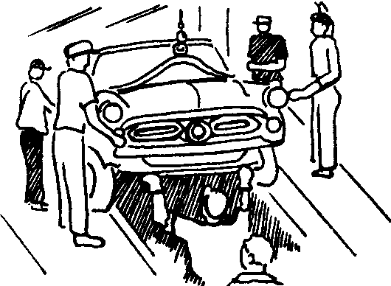
A worker learns the need for cooperation the day he is broken in on his first job. All his feelings and instincts turn that way. But in a factory today every effort is made to stamp out and stifle free, democratic cooperation among human beings. The man is put to serving a machine and it is the position and nature of the machines which determine the cooperation between the workers. Workers want to have a free association in labor in which people can cooperatively and collectively organize and arrange machines and production to suit themselves. They resist every attempt to organize them to suit the machines.

Working people express this in their actions every day. A slow-down in one department of a General Motors plant is typical of the worker's desire to organize production himself. The slow-down was caused by a whole series of petty annoyances, enforcing of company rules, and so forth. Production standards in that department were low enough for the men to be able to finish their work in from one to four hours less than the full shift. Because of the different speed of different machines the whole department could not make its production unless most of the men did get done early. What started the slow-down was the foreman telling a couple of men to slow their machines down to save tools and get better work. To show their opposition these men ran exactly production each hour. They were soon joined by the others and for three or four days the department was short a considerable number of pieces although each man ran his production if he had the stock. When the slow-down was about over, the foreman remarked to a worker:

"I can't tell Joe anything. If I tell him to slow down, he hollers. If I tell him to speed up, he hollers.

Maybe I'd better keep my mouth shut and let him run his job his own way."

The desire, the need, for free cooperation in the organization of production makes itself felt over any other ideas or feelings the worker may have. A worker may be prejudiced against Negroes. But when a fight with the company over production is involved the average worker would join with the Negro on the next machine without a moment’s thought.

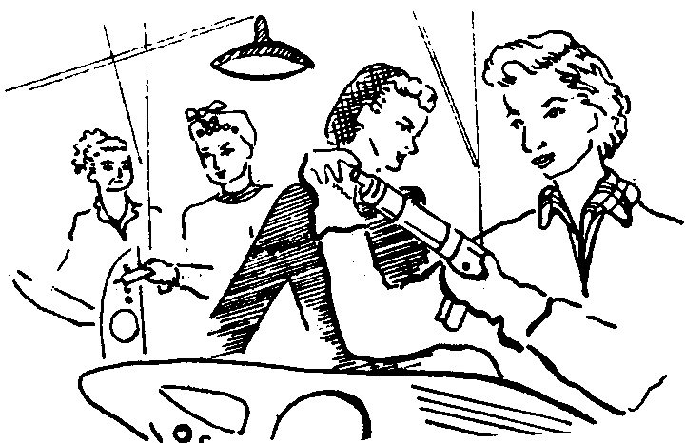
The same is true of workers who may look down on women working in the shop. In a Fisher Body plant in Flint a new department was started up with all women workers, newly hired. Since no one had any seniority or protection of any kind, the bosses rode rough-shod over the girls to establish the highest production standards possible. The men became very antagonistic as they saw work standards go sky high with hardly a fight and the women were bitter because their plight wasn't understood. However, as soon as the first girls began to get their three months service in and acquire seniority they began to fight back vigorously with every trick in the book — jammed air guns, faulty stock, illness, grievances. It was only a short while later that mutual respect and cooperation developed between the women's line and the men's operations that fed them stock and they joined to make life miserable for the foremen and time study men.

"Back To The Mines"

In the factory the worker's desire to organize production can only be expressed in opposition to things as they are, in resistance to company domination. But if you have helped a friend build his house or repair his car you know the release of freely associated labor. Whether your skill is small or great, whether you can do the wiring or can only carry cement blocks, you feel a part of something. There is a holiday spirit when you go out to the lot on a Sunday. Lots of talk, friendly joshing, a picnic lunch. But everyone takes part in the planning and carrying out of the work. Everyone gives the best that is in him and feels better for it. You may have a charley-horse when you go back into the shop on Monday — but it's like going back into a prison after a taste of freedom.

The worker wants to organize production in his own way and it is the fundamental purpose of factory supervision to prevent this. 90% of all company rules have nothing to do with producing the product. They have everything to do with keeping him tied to his machine, with keeping him from learning, with keeping him from doing. Above all they seek to establish the discipline of the machine over the man and a foreman is put there to enforce it.

The average foreman knows no more, and usually less, than the workers under him about production. He is there only to enforce discipline, to see that the workers work. Sometimes company policy is to promote foremen from the ranks, sometimes it is to bring in outsiders completely unfamiliar with the operations. In either case, every worker recognizes that he is there as a policeman. The planning of production is left to engineers, chemists, and others. The basic job of supervision Is to prevent the worker from developing his natural and acquired powers and using them to benefit himself and his fellows.

This aggravating conflict, a daily source of bitterness to the worker, combined with man-killing speedup, long hours, miserable wages, corruption, and favoritism resulted in the tremendous eruption that overwhelmed the country in the formation of the CIO.

"WE'RE TAKING OVER"

The desire of the workers for a new way of life can be seen most clearly in the rise of the CIO, although, to one degree or another, it can be found in all unions and industries.

The organization of the CIO was a nation-wide revolt of the working class against its conditions of life inside and outside the factory. It was a mass attempt to change American society fundamentally by freeing the working people from the domination of capitalist production and establishing in its place a cooperative society of free men.

Long before the CI0, workers, in organizing unions, were looking for more than a bigger pay check. In 1861, and this was not the beginning, a miner in Illinois, calling on his fellows to organize, felt compelled to say:

"In laying before you the objects of this association, we desire it to be understood that our objects are not merely pecuniary, but to mutually instruct and improve each other in knowledge which is power; to study the laws of life, the relation of Labor to Capital; politics, municipal affairs, literature, science or any other subject relating to the general welfare of our class."

Before labor was organized nationally in powerful organizations, before workers could feel their collective strength, thoughts were directed toward the reorganization of any aspect of society — not merely the question of wages and hours.

The spontaneous movement of masses of people in the rise of the CIO cannot be understood in any other way than as a revolt against the conditions of life in capitalist society. This does not mean that the working men and women who took part in that great upheaval knew clearly and consciously what they were doing or what they intended. People who do new things usually think of them in old ways. Most workers thought they were loyal to the American government, to private property, to things as they were. But their actions spoke differently.

The workers, organizing in the CIO, wanted to establish their control over production and to remove from the corporations the right to discipline. Their method was direct action — the carrying out of their own plans for the organization of production to the extent possible. In the first upsurge in the rubber and auto industries the workers in the shops established their own production standards. They announced what they would do and that was it. Their answer to company discipline was the wildcat strike. It was a common practice in the auto shops for negotiations on the shop level to consist of the steward, surrounded by all the men in a department, arguing with the foreman. No one worked until the grievance was settled — and most of them were settled in the workers' favor without the red tape of a bargaining procedure, appeals, and umpires.

One Page Contract

The first contract won from General Motors in the sit-down strike of 1936-37 was one mimeographed page. It merely gave the union bargaining rights for its members. But the old timers look back on that as the contract under which the greatest gains were made because the bargaining and the decisions were made by the workers on the job. It wasn't that the contract was any good. It was that there wasn't enough in it to prevent the workers from doing pretty much as they pleased. Foremen, for the first time, asked the steward how much production the department would get so he could plan accordingly. The steward consulted with the men — and then gave his answer to the foreman.

Not merely on the job did the workers blaze a new trail. The sit-downs themselves were a revolutionary development — the taking over of the private property of the capitalists.

This was not merely an unconscious means to a limited end. The propaganda of the daily press which called the sit-downs communistic and anarchistic made the workers fully aware of what they were doing. The opposition of the labor leaders, such as Sherman Dalrymple of the Rubber Workers Union, or, at best, their concealed hostility, as the auto workers leaders, helped the workers understand the significance of their actions. The workers were showing their power, their organization, their discipline. They were showing that they didn't need anyone to tell them where to go or to lead them there. And before this great new power of labor corporation executives and government officials quaked in their boots. And the labor leaders were scared silly.

Rank And Filers And Leaders

At the meeting of GM strike delegates in Detroit on March 14, 1937, Wyndham Mortimer, then a UAW vice-president, tried to put the delegates in their place. He said: "We've been pretty liberal with you fellows. We've sanctioned all of your strikes even though we didn't know a thing about them beforehand." And Ed Hall, another official, complained at the bitter criticism of the proposed settlement that ''we can't expect to get everything at once." They saw workers organizing and leading themselves and they didn't like it.

During the sit-downs workers who had not even been union members at the start organized a full community life; feeding, entertaining, and protecting themselves collectively with a self-discipline that far surpassed the imposed discipline of the corporations. They cooperatively determined the strategy to be followed and the means for putting it into effect.

In one of the struck plants, a strike leader was trying to get some sleep in a plant office. A worker came in to tell him that the boys were cold and wanted a fire. The leader, half asleep, mumbled, "O.K., build a fire." A few minutes later the worker was back: the men had decided that a fire would be too dangerous. "O.K., don't build a fire." In a little while the worker was back again. "We figured out a way of building a fire in a steel drum that would be safe." And the leader again gave his O.K.

It was like this in most things. The leaders merely put their stamp of approval on what the rank and file workers were doing anyway.

At one point in the great GM sit-down strike a stalemate had been reached in the negotiations. It became clear to everyone that some new victory was needed to swing the balance in favor of the union. The strategy for this victory that turned the tide in the whole GM empire came from the rank and file workers in the Chevrolet plant in Flint. Chevy Plant 4 was a keystone in the whole GM setup. At that time it was the sole source of motors for all Chevrolet assembly plants throughout the country. It had worked all through the strike. The corporation was also conscious of the strategic importance of Plant 4 and it was heavily guarded by company police and thugs. The strategy for taking Plant 4 was very simple — the men had to organize a fake attempt to take a less important plant in order to divert the guards from Plant 4. The leaders of Plant 4 proposed this strategy to Walter Reuther. He opposed it bitterly as being foolhardy and impossible. When he was overruled, he denounced the Plant 4 leader and said he would have his neck if the strategy failed. When it succeeded, of course, he took full credit for it.

The strategy succeeded because it was carried out with the greatest discipline and care. Only a handful of men had knowledge of the details. The taking over of another plant was planned so that word would get to the company. While the company police were busy slugging and beating these workers, Plant 4 was occupied and the foremen thrown out in 20 minutes without a hitch. And the production of Chevrolet motors came to a stop.

Not only were relations between the workers and corporations changed in the great CIO strikes, but the men themselves were changed. Talking to sit-downers, you learn of the tremendous discoveries they made of the powers they had that they didn't know about before, powers that were released when they were released from the immediate domination of the machine. Men who were unable to talk in the presence of more than a couple of people spoke to hundreds and thousands with ability and confidence. Men found they had organizing ability, or could do office work, or direct a military operation. Only in free cooperative effort with their fellow men could their own powers and abilities be released and developed. It changed their relations with their families, their outlook on life, the very nature of their being. They felt, at least for a while, what it was like to be a whole man, not just one part that was needed to tend a machine. Countless numbers of women achieved a new measure of equality in the home and in the factory — not from a contract clause —but from participation as equals in a collective struggle.

The women who threw bricks at the cops in the Battle of Bulls Run on Chevrolet Avenue in Flint were no less men, that is, free human beings, than the men who threw bolts from inside the plant.

The taking over of the plants of the corporations in the sit-down strikes was but a step removed from the action of Japanese transportation workers after World War II who operated a municipal transport system themselves during the course of a strike. Both are pointed at the complete control and organization of production by the workers themselves.

In the anthracite coal fields of Pennsylvania, when the depression of the 1930's saw the closing of many mines, miners returned to the pits and mined coal for themselves, making agreements with truckers to take their coal to city markets. This production of coal by the miners themselves lasted for years in spite of the attempts of the state police and coal and iron police to evict them by force.

Battle For A Mine

An auto worker I know told this story of a visit to his wife's relatives in a Pennsylvania coal town. One morning his father-in-law invited him out to "see some fun." They went a few miles to a hillside where a mining company was going to start a huge new expensive mining machine. Workers had been surface mining on their own and the company was figuring on restoring profitable operations. The two men stopped a short distance away. Surrounding the machine was a group of heavily armed coal and iron police. Scattered over the hillside behind cover were a number of miners with rifles and shotguns. Off to one side were some state police.

One of the miners came down to negotiate with the company manager. After exchanging threats and warnings, the miner was told the machine was going to be started up. He turned and ran like hell for cover, followed by the bullets of the coal and iron police. A pitched battle followed in which several men were killed on both sides. But the coal and iron police were forced to retreat. The state police remained on the sidelines. After the battle they removed the dead and wounded. And then the miners started up the new machine and ran it off the edge of the hill, smashing it completely.

The basic character of the change they wanted was clear in the minds of many workers. A large number of secondary and even higher leaders of the CIO were members of parties that in one way or another claimed to stand for socialism. The entire leadership of the GM sit-downs in Flint, for example, was in the hands of known socialists and communists. This was carefully exposed by the press and yet the workers stuck by them. Members of the Socialist and Communist parties, Trotskyists, Lovestoneites, Proletarian Party members, Wobblies — all came to the fore during the strike wave.

The Communist Party of Flint in the year following the organization of GM had between 900 and 1000 members out of about 30 or 40 thousand workers. The Socialist Party had about 400. This is a phenomenal number of declared socialists and communists, a truly mass organizational response by the workers. While most of these members were lost in a year or two, it is clear where they stood in 1938.

The temper of the workers in those years is best illustrated by the action of a leader of the Buick Local in Flint in 1940. Following the split of Homer Martin from the CIO, a Labor Board election was required at the Buick plant to determine which faction represented the workers. The struggle for the election was marked with considerable violence, roving goon squads, raids on the union hall, and the like. The Martin faction had considerable strength on the surface. When the CIO won the election, there was quite a celebration and considerable consumption of whiskey. A member of the shop committee marched through the gates of the plant, past guards and secretaries, and into the office of the plant manager. He banged his fists on the desk and shouted: "Get the hell out of that chair you son of a bitch, we're taking over!" The plant manager just grinned and said: ''So you won the election." But what the workers felt the union meant to them was clearly there.

WHOSE CONTRACT

With the rise of the CIO, it was no longer possible for the capitalists to control the men and manage production. A new force had arisen which challenged the control of capital at every step. Plant supervisors were unable to cope with it. The factory was no longer entirely their own.

Even more than the corporation executive, the labor leader feared and hated this power that he couldn't understand. No more than the capitalist could the labor leader conceive of workers organizing production and society themselves and throwing him on the scrap heap. From the very beginning, all his efforts were directed toward keeping the worker tied to the machine. And the labor leaders, because they came out of the working class, were able to reestablish some order and discipline in the factory where the foreman or superintendent was helpless.

What they feared most was the independent action of the workers to solve their own problems for that was too striking a sign of things to come. The leaders would promise anything, demand anything, provided the workers would let them go about it in their own way – while the worker kept his mouth shut and worked his job.

Wherever it was possible the bureaucrats tried to prevent any action by the workers in advance.

John L. Lewis spent more than ten years ruthlessly wiping out any opposition to his machine in the United Mine Workers. In doing that he ran the union into the ground. But it wasn't until he had total control of all the districts and national and regional contracts that left the locals out in the cold that he embarked on the organizing campaign of the early 30's to rebuild the union. The hundreds of thousands of miners that entered the union found an iron dictatorship in which all decisions were made at the top. Demands against the mine owners, strikes, all policies were decided by the International Union.

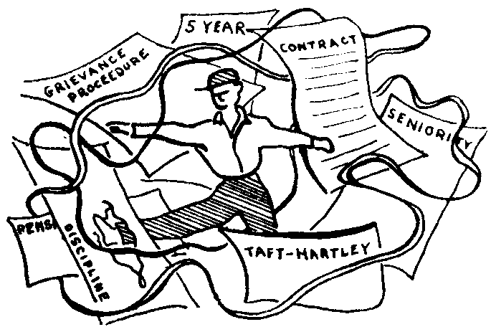
In the steel industry the CIO did exactly what it charged the AF of L with doing — it refused to charter an international union until most of the industry was organized and all policies, contracts, and leaders were decided by the CIO officials. Philip Murray was put in charge of the Steel Workers Organizing Committee and its policies were determined by the top CIO officials. As a result, organizing drives were based on negotiations with company unions, peaceful secret negotiations, or, at the most, "legal" strikes. The fruits were an agreement with U. S. Steel in which the steel workers played no part at all and a catastrophic strike in Little Steel which was smashed with the murder and beating of steel workers who were kept in check by Murray's tight control of the union.

When the Little Steel strike was losing ground, Mine union locals offered to declare a holiday and send tens of thousands of miners into the steel towns to turn the tide. But it was more important to prevent the workers from learning their own power than to win the strike so Lewis prevented the plan from going through and the strike was lost.

The United Auto Workers was already chartered when the CIO was formed and it was impossible for Murray and Lewis to impose their policies on the new union directly. It took ten years of constant sniping and the help of the government before Reuther's machine could achieve complete control of the union. To this day, the auto workers, who saw what they could do in 1937, have not submitted to the kind of dictatorship established by Lewis and Murray.

Each union has its own history. But in each the action of the union bureaucrats is the same. Clamp down on any attempt of the workers to free themselves.

The basic means of doing this is the union contract. The workers were moving to organize production for themselves. The union leaders, in Ed Hall's words, said: "We can't expect to get everything at once." Let's stop and set down the gains we have made so far. By maneuvering, by lying, by outright fraud, the first contracts were imposed on the workers.

The contract is a contradictory thing. To begin with, it records the gains made by the workers, the wages, the hours, the right to representation. Putting these gains in a contract makes them secure, or so it appears. But for every advance made in a contract a price must be paid. The fundamental cost was reestablishment of the discipline of the company. The contract gave to the company what the workers had taken away — the right to organize and control production. The complete recognition of a grievance procedure meant the establishment of a structure of red tape where the worker lost his grievance. To end the constant battle over members, the union won the union shop and the dues checkoff — and paid by removing the union another step from its membership.

The more "victories" it recorded, the bigger and more technical the contracts became. The union militants of '36 and '37 began to drift away and the contract lawyers and porkchoppers and specialists took over. Workers stopped going to membership meetings because instead of activity and the chance to solve their own problems directly they were presented with debates on technicalities and the maneuvering of rival factions. The initiative was taken away from the workers and given to the officials.

A contract is a compromise. That establishes that, no matter what union gains are recorded, the rights of the company to manage production are also recorded. And in the grievance procedure it takes the power out of the hands of the workers and puts it in the hands of the stewards and committeemen. The union officials become the enforcers of the contract and the union becomes the agency by which the worker is disciplined and tied to the machine.

A Steady Grievance

The heart of the contract is the grievance procedure. Through it is established a certain measure of control over production. An especially severe penalty against a worker may be lessened or a very unjust one eliminated. But basically the right to discipline remains. And that is cause for most of the friction, the humiliation, the dissatisfaction in the shop. It is a steady grievance. But, as the UAW magazine, "Ammunition," points out, "there is no remedy for most of the grievances a worker has in a plant." Not under the contract, that is.

A boss sees a worker standing around and says: "Grab that broom and keep busy." The worker has done his work but still he cannot say no. He asks for his steward. To protect the worker from a reprimand or a disciplinary layoff he must advise him to obey the foreman's order and file a grievance. In other words, as a normal feature of his duties, the steward or committeeman must stand by the right of the foreman to order people around. Most workers have seen many, many cases where, without the union representative, the foreman could not have had his orders carried out. How many times has the natural reaction of a worker to a foreman's order been: "To hell with you. Shove the broom up your --- !" But the steward or committeeman explains to the worker what he can and what he cannot do and the worker picks up the broom.

The grievance can do absolutely no good. Even if it is won, all it does is establish that the foreman should not have issued the order. That is small comfort to the worker a month or so after it happened when he knows that the next day it can happen again and he will once again have to go through the same farcical procedure.

What happens is what happened to one worker who was moved to a job he didn't like. He consulted with the committeeman and the foreman and got nowhere. Finally, in disgust, he walked into the office of the superintendent and cursed him viciously. The stakes are high in an action like that — it's your self-respect or your job. And the pressure of the machine and the discipline that ties you to it is tremendous to provoke such actions continuously. As it happened, the same day the man was put on his old job. Shortly afterward the men around him asked him to run for committeeman: but he hesitated because he knew how little he could do with the contract even with the best will in the world.

More and more workers recognize the contract for an enemy every day. And with the contract. the committeemen and stewards who enforce it. Workers go out of their way to circumvent and ignore the grievance procedure or humiliate the union representative.

At an AC Spark Plug plant during the last war a group of workers were plagued with extremely poor working conditions, dust and speed-up. After a few weeks of bearing this and griping among themselves, they decided they had had enough. They all stopped work. The first one over to get them back to work was the committeeman. He was very nervous, wanted to know what the trouble was, and told them to get to work and he would try to help them. They contemptuously refused to give him their grievance, treated him like an errand boy, and told him to get supervision. When he did, they negotiated directly with the boss and settled the matter in 15 minutes.

Union Frightened By Workers

It is no wonder that union representatives are as frightened of the workers as supervision. They have much more in common with the foremen with whom they bargain than with the workers who they are supposed to represent. Very often, when he gets in a jam with the men, it is the foreman who sends for the committeeman to straighten things out and put the men back to work.

But can't the contract be improved? Can't the compromise get better and better over the years? The fact of the matter is that the contract can only get worse. It turns every gain of the workers into its opposite, a weapon of the corporations and the bureaucracy.

Holiday pay, for example. It is an important financial gain for the worker and recognizes his right to paid leisure time. It is put into the contract and it becomes a means of keeping the worker on the job. If, as sometimes happens, there is a four day holiday weekend, the worker finds it much more difficult to take the whole weekend off because he loses not just the pay for the work day, but also the holiday pay. From being a payment for a day off on Thanksgiving, it becomes a means of getting him back to work on Friday instead of the following Monday, if the company sees fit to work the plant that day.

One of the most important gains that workers have made is the establishment of seniority in the plants. It was necessary protection against discrimination; against men being laid off and hired at the whim of the foreman; against having to get the foreman presents or doing work for him to keep your job; against being forced out when you get too old to suit them.

But at the same time, so long as capital dominates production, it is a means of keeping the worker tied to his particular job. He cannot go to another plant to try for something better because his seniority is too important to lose. It puts the younger worker at the mercy of the slightest change in the economic scene, subject to frequent layoffs and insecurity. It prevents the men from using their ability and even from gaining experience and knowledge.

The worker recognizes the contradictory nature of seniority and while he will defend it against any encroachment by the company he wants to organize production in such a way that the protection of seniority won't be necessary, that no protection will be necessary, since no one will be there to dominate him.

Left Wing Porkchoppers

The so-called left wing caucuses and unions that oppose the existing trade union leadership do not understand this. Some may be dominated by the Communist Party. Some are not. But they all propose only to patch up the old contracts here and there. Basically they want to substitute themselves for the pork-choppers in power. And that is why they have had such little success. When the workers decide to throw out the old labor leadership, it will not be to substitute these petty politicians that want to set themselves up as an alternative bureaucracy.

The union leaders alone could never have prevented the workers from achieving their objectives in the 1930's. But they had allied with them the whole machinery of the government and that huge structure of government agencies designed to control the workers known as the New Deal.

When the working class began to strike out on its own, throwing its shackles aside, the union bureaucrats sought to bring in an outside force to put on pressure for adherence to contracts. In this they had the willing cooperation of the more far-sighted members of the government, above all, Franklin D. Roosevelt. The main objective was to take the initiative away from the workers, to make them dependent on leaders, to keep them from using their own knowledge and their own strength.

To accomplish this objective a huge mass of so-called social legislation was put on the books. Just as in the contract, here, too, these laws recorded the gains made by the workers in struggle. Where the workers weren't strong enough to win them on their own, they didn't get them. But it recorded these gains in order to take them away.

Laws were passed to remove the sharpest stings of the system. Unemployment was slightly relieved through insurance, work projects, and direct aid — after organizations of unemployed had been formed that were marching on state capitals to take what they wanted. Laws were passed easing up on farm mortgages to keep farmers from defending their farms from the sheriff with guns in hand. Other legislation of the same kind was passed, all designed to make the worker dependent on government action rather than on his own action — because his own action meant that he was setting about to run things himself.

Keystone of the New Deal structure was the Wagner Act, the National Labor Relations Act. In this law the workers were granted the right to bargain collectively, a right they had already won in practice on the picket line. The employer, if he was so benighted that he could not see that he wasn't getting anywhere the old way, was required to sign a contract with the union. And just in case the contract didn't hamstring the worker enough in red tape, or the employer was adamant, the law set up a grievance procedure that paralleled the grievance procedure in the contract. Only this one was better — it went all the way to the Supreme Court. Where a contract could tie up a grievance for months, the NLRB could keep one in the mill for years. Instead of a steward or committeeman to represent you — he may not have been any good, but at least you knew him and could put some pressure on him — you got a lawyer to represent you. That was a couple of years they could keep you working on your job (or fired from your job, if that was your grievance) when you could settle it in hours or days if you and the men around you had a free hand.

"Don't Rock The Boat"

The whole set-up was carefully designed to show the worker how everyone was looking after his welfare —if only he wouldn't rock the boat. It was also designed to show the worker how inferior he was, how unfit he was to deal with such complicated legal and technical matters. He had best leave them to his union leaders, the government boards, and the corporation lawyers.

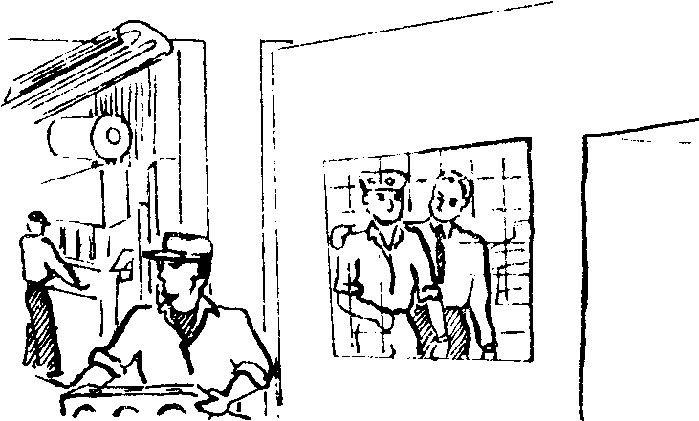
What started out as resistance to the advances of the workers under the New Deal was turned into an offensive against the workers under the War Deal after 1940 and then continued in the Fair Deal. During the war union bureaucrats and government bureaucrats clamped down on strikes or any other action by the workers directly. Or rather tried to, for they never succeeded in stopping the ceaseless activity of the workers in the plants. The UAW officialdom succeeded in passing the no-strike pledge in a union referendum to free themselves from some of the bitter criticism of the ranks. But the rank and file showed what they thought of the pledge when the Majority of them struck and struck again during the course of the war.

Union bureaucrat and government bureaucrat came to depend more and more on each other during World War II. The union leaders would blame certain "bad" government officials for the straightjacket that was being put around labor and the government would give the union leaders a few more miles of red tape with which to trap and tie the rank and file workers. The military arm of the government intervened openly in labor relations. In direct strike breaking, as when the army took over the North American Aviation Co., or indirectly, as in the activities of the infamous Col. Strong who infested Detroit and the midwest industrial region, injecting himself in every labor dispute, seeking always to stifle the initiative of the workers.

Today, with union official and government official preparing vigorously for war, the same thing goes on at an increasing rate. Reuther uses the Taft-Hartley Act to cut down any opposition to him in the union. Union administrations finger militant workers to the Army or Navy in plants that have war contracts —and they are fired. But the tie-up between government and union has reached its most advanced stage in the maritime industry. In the National Maritime Union, Joe Curran openly called on the New York Police Department to help him establish dictatorial control in the union. Police ringed the convention hall. They controlled the microphones. They threw out opposition speakers. They turned the names of opposition delegates over to the Coast Guard to lift their seamen's papers. On the West Coast the same situation exists. In the seamens' unions there the Coast Guard and union officials rule with an iron hand. The union leaders blame it on the Coast Guard, but the members know better. No one dares criticize official policy because it means getting tossed on the beach by the Coast Guard.

But basically the union official who uses the Coast Guard to throw a man off a ship is doing the same thing as the committeeman who orders some men back to work in an auto plant. Both of them have become agents of capital.

When Reuther signed his five year contract with General Motors in 1950, the most popular phrase among GM workers was "Reuther's Five Year Plan." In this was shown the deepest understanding of what Reuther and the labor bureaucracy represent. Reuther was taking the place of management as the power that disciplines the workers and keeps them on the job. C. E. Wilson, president of GM, also recognized this in speeches all over the country praising the five year contract as the only guarantee of labor peace. But it is more than that. The "Five Year Plan" shows that Reuther is not merely willing to cooperate with management and the government in keeping the workers in their place. It shows that he is perfectly willing, if the opportunity and need arise, to impose the same type of total domination of the working class that Stalin and his five year plans have imposed on the workers of Russia.

WITH OPEN EYES

The working dass today recognizes the labor bureaucracy as an enemy, as an administrator of capital. They look to the union as a source of strength, as a means of keeping the gains they have made over the past years. But they do not look to the union for the next steps to be taken. They resent and oppose the domination and interference of the union bureaucracy.

In the vote on the union shop in General Motors a few years ago, the sentiment in the shop was overwhelmingly against the union shop. To the worker it was just another means of strengthening the union bureaucracy. But the question was put in advance of contract negotiations in such a way that the union shop vote was made a test of strength between company and union. As a result the GM workers were forced to vote for the union shop against the company. But being caught in the middle between Reuther and GM only served to increase their hatred of Reuther.

The workers are conscious of the fact that the old days are gone. There can be no return to 1937. The union and the contract have outlived their usefulness. The union is no longer a place where the worker can express his views. The struggle between powerful caucuses, each appealing to the rank and file, as in the early days of the UAW, is a thing of the past. The worker may support one caucus or another, or, as is more likely, none of them, but he does not look to them to determine his future. His view of the union bureaucracy, no matter what its program, is one of complete hostility.

The working class has already left the old road of simple trade unionism. It has turned its back on penny gains that change nothing. Nothing was more complete than the contempt with which the auto workers received Reuther's pension plans. The working class has left the old road and embarked on a new one. It has not given the new road a name. It is not fully conscious of what it is doing. But in its actions it has pointed the way.

A worker cannot remain a human being without fighting against the domination of capital, of the machine. It is this daily, ceaseless resistance that calls forth the repression of capital, of the labor bureaucracy, of the government. But none of it can keep the worker quiet. At every opportunity he bursts forth, exercising his human powers, seeking to develop them further. Bureaucrat is piled upon bureaucrat and the worker shrugs them off and continues to disrupt production.

Workers Organizing Production

Somebody has to organize production. As long as the worker doesn't organize production there is going to be a bureaucracy. There is going to be a constant crisis because the workers won't let anyone else organize production at their expense. The only answer is workers organizing production. Not nationalization, not this scheme or that scheme. But that someone organizes production who is in a position to organize production — and nobody else is.

He wants to put an end to the whole nightmare of factory work as it is today. He wants to work in free association with his fellow men, to plan and organize production for society as a whole. He is showing the new society in his every action today.

In a department of the Dodge plant duving World War II there was a girl who knew how to set hair. It became the regular practice for the girls to have their hair set by her during working hours. This became a cooperative enterprise of the whole department for when a girl was having her hair set the rest of the department chipped in and did her work and the work of the hair setter.

In the same plant a matron, who was able to enter and leave the plant more easily than production workers, would go around to the girls in the morning taking orders for various things that they needed. Then she would go downtown and do everyone's shopping. While she was gone all the girls would share her work, keeping the wash basins clean and the floors swept.

In a department of the Buick plant in Flint it is the practice for a man who goes home sick during the day not to punch out. The men cooperate in putting out his production and then someone punches him out at the end of the shift.

Example can be added to example of workers organizing production to suit themselves within the limits that it is possible under capitalism. The corporations recognize this and attempt to break it up. When a group of workers gets along too well, have too good an understanding of how to beat the company, there is often an attempt made to transfer some of the people to other jobs to break the group up. Or some are put on jobs that keep them tied down.

But workers are constantly evading these limitations. Workers will keep a man's job going for an hour or two so he can visit friends in another part of the plant. Or they will cover up for him to the foreman. Very often the foreman, to maintain any kind of relations with the workers, has to go along with them and looks the other way.

Sometimes even higher management is forced to depend on the ability of the workers to organize production. They try to limit this as much as possible. But within these limits they often have no choice but to rely on the workers' organizing ability. When there is a model change in the automobile industry, especially when there is a major change, time study men will be kept away and foremen will leave the men alone for as much as a month or longer until production of the new model is properly organized. It takes more than engineers' blue prints and the power to discipline to organize production.

In an auto body shop, during a model change, an engineer came down to one department and told the workers that under the new set-up the line would be run the other way. One of the men told him he was nuts, it wouldn't work. Later in the day the superintendent came down to find out why the engineer got mad. The worker told him. And the superintendent said, "Don't worry about him, we'll keep him out of here. You and I will get production organized here." Of course, all the superintendent could do was keep the engineer away. The workers would have to do the organizing.

When the company doesn't leave the workers alone they get paid back in kind. A sub-assembly line in one plant was reorganized and the women who worked on it could see at once that it wouldn't work the way the foreman worked it out. As long as the foreman was around they followed his instructions to the letter — and really fouled up the job. As soon as his back was turned they got the line running smoothly. But whenever he came around they went back to his plan of production, fouling up the job again. It was a long time before that company got any kind of production off that line.

Numerous other practices in the plants show the workers' desire to cooperate freely and fully with his fellow workers outside the direct process of production. The numerous collections for flowers or gifts for fellow workers and their families and especially the way these collections are systematized. When the collections are haphazard, workers begin to resent the fact that some receive more than others, depending on the number of collections during the week. In plant after plant they organize regular funds, often with bonded collectors, to insure regular contributions and the equalization of gifts.

The New Society

In all this the new society appears within the old. A society in which the workers, every one of them, takes his part in planning production, in carrying out the plan, in developing himself by helping his fellow men, in helping society by developing himself. It means the total reorganization of society inside the factory and outside the factory, a society of freely associated men under no one's domination.

It is this that the workers are driving toward today, in ceaseless struggle. It will take only the slightest spark to set off the tremendous explosion that will unite the small groups of workers buried in a thousand factories and mines, that will transform the million actions directed at one end into one action achieving that end. In this upheaval the labor bureaucracy will be the first to fall, unwanted and unlamented by people who have taken their destiny into their own hands — to a man.

