Immigration, Class Recomposition,
and
the Crisis of the “Labor Market”: The Canadian Case.
by
Bruno Ramirez

“Has the world really gone downhill that swiftly in the nine years between the White Paper on immigration policy of 1966 and the green paper on immigration published Monday?” (The Globe and Mail, Toronto, February 6, 1975)

1966: The Canadian government took a new look at its immigration policy which had regulated the flow of immigrants into Canada throughout the post-World War II period. This “New Look” was expressed in a White Paper arguing the need to rationalize the flow of immigration as a function of the needs of a growing economy and of a diversifying labor market. This new look led to the passing of a series of regulations designed to change the composition of incoming immigrant labor power, so as to lead to a qualitative expansion of the Canadian labor market. For the first time, restrictions on the basis of racial origin were dropped. The Canadian economic boom, it was felt, would rest on a “multicultural” working class that would enrich the Canadian dream of affluence and prosperity.

February 1975: The Department of Manpower and Immigration renders public a green paper on immigration designed to generate a national public debate on a topic which is considered to be of critical importance for the future of the country. Two and a half years later, the green paper proposals, enriched and impoverished by the public debate, leads to the passing of sweeping legislative measures designed to impose very stringent conditions on prospective immigrants to Canada.

From the glowing optimism of 1966 to the gloomy scenario of 1975 – if the world had not entirely “gone downhill” – something very important had happened which reveals the role of the immigrant working class in the capitalist crisis, and which points to a crucial dimension of international class conflict which is operative today.

I

If the immigration issue has become in recent years such a heated question, this is because immigration and ethnicity have played a central role in the economic, social and political development of Canada (and this is quite apart from the existence of the two official founding groups, i.e., the French speaking and the English speaking ones). This has been particularly true for the post-World War II period, when Canada began to resort massively to immigration in order to deal with a very acute shortage of labor power – a shortage made even more serious by the prospects for development which lay ahead. From 1946 to 1966, no less than two and a half million immigrants were admitted to Canada – an influx which played a vital role for the development of the Canadian economy, especially when one considers that for the decade of the 1950s almost one half of the total labor force increase in Canada came from immigration. So drastic was Canada’s need to build up its labor market that practically all sectors of the occupational spectrum were represented in this immigration wave, from professional and highly specialized to unskilled labor.

Attracting professional and technical labor did not pose so much of a problem on account of the ample availability from the two major English-speaking countries, i.e., the USA and Great Britain – and thanks also to preferential immigration policies facilitating its recruitment. More problematic was the mass recruitment of unskilled labor. With the existence of a race-based quota system limiting the inflow of Black and Asian immigrants, the only recruiting area was Europe – and particularly those countries which in the post-war years were contributing to the world capitalist growth by tapping their vast resources of mostly unskilled labor power.

Much has been written in recent years about the crucial role played by this flow of unskilled immigrant labor in the re-building of post-war economies, particularly in Western Europe. And in Canada too, few people would question the contribution of post-war immigrant labor to the population and economic boom the country experienced in the 1950s and 1960s.

What is important to point out here, however, is the particular approach the Canadian government took to facilitate the recruiting of unskilled immigrant labor. This approach was embodied in a policy known as the “sponsorship system.” Prospective immigrants could be allowed into Canada as long as they had at least a relative – no matter how distant the kinship relation – who would act as a sponsor and assume responsibility for their settlement into Canada. Consequently, between 1946 and 1966 over one third of all immigrants admitted into Canada were “sponsored immigrants”, and they came almost entirely from Greece, Italy and Portugal. Italians constituted the largest ethnic group, representing 40 percent of the sponsorship movement.

As if the urgent labor-market needs were not sufficient justification for this approach, Canadian policy-makers went a long way explaining to the public that humanitarian considerations dictated the sponsorship policy; namely, the recognition of strong family ties characterizing rural Southern European immigrants, and hence the concern to enable members of a household to be reunited in their new country of work, rather than be divided by immigration.

Of course, it is irrelevant for our purposes to question the sincerity of these humanitarian considerations; what is more relevant is to point out, instead, the extremely important repercussions that the sponsorship that the sponsorship movement had on the socioeconomic and political configuration of Canada, especially when one considers the relatively short period of time during which this policy was operative, the large amount of labor-power it moved, and the pre-existent population and labor-market structure of Canada.

It is no exaggeration to say that the “sponsorship movement” was the main vehicle through which the unskilled labor-power needs of the 1950s and part of the 1960s were filled. It also permitted the integration of the newly arrived immigrant workers into the labor market at a minimum social cost, in that much of the burden in gaining access to the labor market and of servicing such a process was placed squarely with the immigrant family or household. It was the immigrants’ responsibility to learn the language(s) if they wanted to take better advantage of the job availabilities or if they did not want to be ripped off by their bosses; it was their responsibility to learn some other trade if they wanted to up-grade their labor-power; it was their problem to look after themselves in case of work accidents or unemployment.

Clearly the humanitarian considerations mentioned above were paying off for the immigrant family/household was functioning as a unit of service and reproduction, and as a shock-absorber for the immigrant workers and for the labor market.

Just as, at the dawn of manufacturing capitalism, employers were discovering the magic of “simple cooperation” for factory production, so the architects of the sponsor movement couldn’t turn their face away from the advantage of kinship reunion and cooperation, i.e., economic and cultural survival, and from the magic blessing that societal norms, traditions and mores could bestow upon the “social factory”, if only they were acknowledged and properly valorized.

A related outcome of this process was the emergence of new “ethnic ghettos”, particularly Italian, Greek and Portuguese ones, which on a larger scale than the single family/household played the immediate role of social organization of alternative services, producing their own job networks, information and mutual assistance networks, its own entrepreneurial class, etc. – even if in the long run, owing to its almost self-imposed cultural isolation, the ethnic ghetto would become the object of political and economic instrumentalization, and would become an important mediating vehicle for the control of the immigrant working class.

Clearly the provisions of the sponsorship policy facilitated the “pull-factor” acting more swiftly, thus also promoting the geographical concentration of immigrant labor power around the major poles of industrial development. Canadian policy-makers who in the 1970s would decry the congested urbanization of areas such as Southern Ontario and Montreal (often blaming the immigrants for this) conveniently forget that these were the two major poles of industrial development; they also forget that the three major industrial sectors on which much of the economic boom of the post-war periods rested, i.e., construction, manufacturing and services, were the ones which most needed to attract the large majority of unskilled and semi-skilled immigrant labor.

By the end of the 1950s, however, this climate of uncontrolled labor-market buildup was beginning to be perturbed by new economic and political developments. The country was hit by a recession which lasted for three years and which coincided with the so-called Conservative Party interregnum. Perhaps the most conspicuous aspect of this recession was the dramatic rise in unemployment, which in 1962 reached almost 7 percent. For a country which had begun to taste the good flavor of prosperity and which had committed itself to the principle of full employment, the sudden arrival of the specter of massive unemployment came as a disturbing surprise.

It is against this background that one must view the changes in labor-market thinking and policy that would soon follow. The return to power in 1964 of a Liberal government took place just as the economy had entered a new cycle of expansion which would prove to be the “longest peacetime expansion in Canadian business cycle history” (ECC,FH 140). The new Liberal government showed itself to be much more willing to take bold steps toward overhauling and rationalizing economic and social policies in keeping with the structural changes taking place in the Canadian industrial apparatus. Manpower thinking and policies figured very high in thelist of priorities.

For one thing, the coexistence of unemployment and prosperity was seen as essentially the product of poor utilization of the available resources of human capital, both domestically and internationally. Moreover, new important pressures were acting on the Canadian labor-market, such as the massive entrance into the market of the “baby-boom youth”, and the increasing growth and importance of the service sectors – as “lubricant” of industrial growth and accumulation. Hence, the importance of resorting to measures insuring greater control of both the inflows of labor power and the reproduction of the labor market.

In the Keynesian outlook of a balanced growth promoted by the new Liberal technocrats of the 1960s, the Canadian labor market was being viewed less and less as a byproduct of economic forces and increasingly as a central terrain for direct governmental intervention.

The most immediate conclusion reached in this climate of reorientation was the declining need of immigrant skilled labor. In other words, it was felt that the conditions insuring adequate supplies of unskilled labor from domestic sources had been realized. Hence, the need for restrictive measures on the inflow of immigrant unskilled labor – inflow which as we have seen had been secured to a great extent through the “sponsorship system.”

This new orientation which had been in gestation since the access to power of the Liberal government gained momentum as the need to better gear the labor market to the demands of a booming economy made itself felt. It became concretized and translated into new policies in 1967 through the so-called “White Paper on Immigration”. The function of coordinating the country’s manpower requirements with the recruitment of immigrant labor was assigned to a newly created federal department – the Department of Manpower and Immigration. At the same time, the government launched a national plan for the creation of adult retraining centers and technological colleges. Moreover, the government made operative the principle of universality in immigration (admission without regard to the nationality, race, color or creed of immigrants) which had been sanctioned in 1962 but had remained a symbolic gesture more than anything else.

From any standard, this was a liberalization of immigration policies. What this meant, in effect, was that Canada had made a major step in order to gain a more advantageous position in the international labor market, partly to offset the decline of inflows from traditional sources. It did so by enlarging the sources of supply of immigrant labor, and at the same time upgrading the quality of the new labor inflows.

Hence, the most immediate effect of the new policies was the drastic curtailment of the “sponsor movement”. The fear that the sponsor movement contained a “potential for explosive growth,” “the dilemma that unskilled workers may be an increasing part of the immigration movement,” and the realization that “the proportion of jobs requiring little education or skill is declining,” were all dealt with by giving the axe to the sponsor movement. Henceforth, only members of the immediate family could enter the country as sponsored immigrants on humanitarian grounds, to maintain the principle of family reunion. At the same time, to meet current and future needs of a more qualified and “requalifiable” source of immigrant labor, a new category of immigrants was created: the nominated relative.

The criteria for the admission and selection of nominated relatives were based primarily on long-term labor-market considerations, and partially on the kind of short-term settlement arrangements provided by their relatives in Canada. Hence, out of a score system of 100 units of assessment, 70 concerned factors such as “Education & Training”, Occupational Demand, Occupational Skill, Personal Quality and Age.” The other 30 were based on the settlement arrangements just mentioned.

Table 1 (p. 5) shows the incidence of this new category of immigrants within the post-1967 immigration inflow, and Table 2 (p. 6) shows their quantitative contribution to the Canadian labor force as compared to that of the sponsor immigrants and of the “independent” immigrants. Clearly the marked reduction in the inflow of sponsored immigrants was being more than compensated by the entrance of the new category. As to the “independent” immigrants – a category which had always existed – its inflow continued to maintain its relatively autonomous course, as their selection and admission was entirely based on labor-market considerations.

It is also important to look at the new skill composition of immigration after 1965, according to figures and breakdowns provided by the Canadian Department of Manpower and Immigration. They show that while the proportion of unskilled immigrants admitted from 1966 on stabilized around 10 percent, the proportion of semi-skilled more than doubled in 10 years, passing from 15.3 percent (in 1966) to 36.6 percent (in 1973); and, at the same time, the proportion of skilled declined markedly from 74.3 percent to 50.9 percent during the same period of time. Although statistically we cannot match these percentages with the sponsor/nominated/independent breakdown, one can safely infer that the overwhelming majority of nominated were semi-skilled, and also that an increasing portion of independent were semi-skilled.

The new “nominated” category was often presented by policy-makers as a sort of compromise between those who wanted to maintain intact the sponsor system and those who wanted to abolish it all together. In effect, the “nominated immigrant” represented a very important social figure in the evolution of capital’s labor-market strategy. It concretized the shift in orientation (as far as immigrant sources of labor power were concerned) away from unskilled labor and toward semi-skilled labor. In the new context of a booming and rapidly diversifying economy, it seemed that this kind of labor-power would have played a central role in labor-market dynamics: its availability for work and its high degree of adaptability would have afforded the necessary labor-market fluidity, thanks also to its economic dependency on the receiving relatives. In that climate of technocratic optimism who would have guessed that nine years later the nominated immigrant would become the central target of the government’s new sweeping measures?

Capital can go shopping; it can plan the quantity, the quality and the utilization of immigrant labor power; but it cannot plan, nor insure, that that labor power’s behavior will remain passive, complacent and functional to capital’s needs. Capital cannot predict with precision if and when this class begins to articulate new needs and shows itself ready to fight for these needs. This is in fact what happened between the passing of the “White Paper” measures and the recent sweeping new immigration policy.

To most observers, including the Canadian Left, this process has passed unobserved. In the best of cases, it has appeared as a series of fragmented events, eruptions, which have provided the occasion to decry Canada’s incipient nativism and the government’s harsh and discriminatory treatment of both legal and illegal immigrants. Only rarely, if at all, has this process been viewed as an important component of class dynamics. True, very crucial national issues have dominated the political and economic life of Canada over the past 9 years – central among them the dramatic escalation of the conflict between Quebec nationalism and the pro-federalist forces, and the widespread social tensions brought about by the worsening of the Canadian economy, especially since 1973. Yet, behind the seemingly isolated and fragmented events that have characterized the “immigrant problem” of these years there is a constant thread which has been central to the political recomposition of the working class in Canada. Although this process of class dynamics requires more detailed reconstruction than can be provided here and now, some of its central features have become visible enough to warrant some preliminary conclusions.

II

One important consequence of the 1966 changes in immigration policy was that of making Canada more vulnerable to the international circulation of class struggle. Firstly, in order to better compete in the international labor market – particularly for semi-skilled and skilled labor – Canada had to drop its racially based quotas, and thus open its borders to Third World countries.

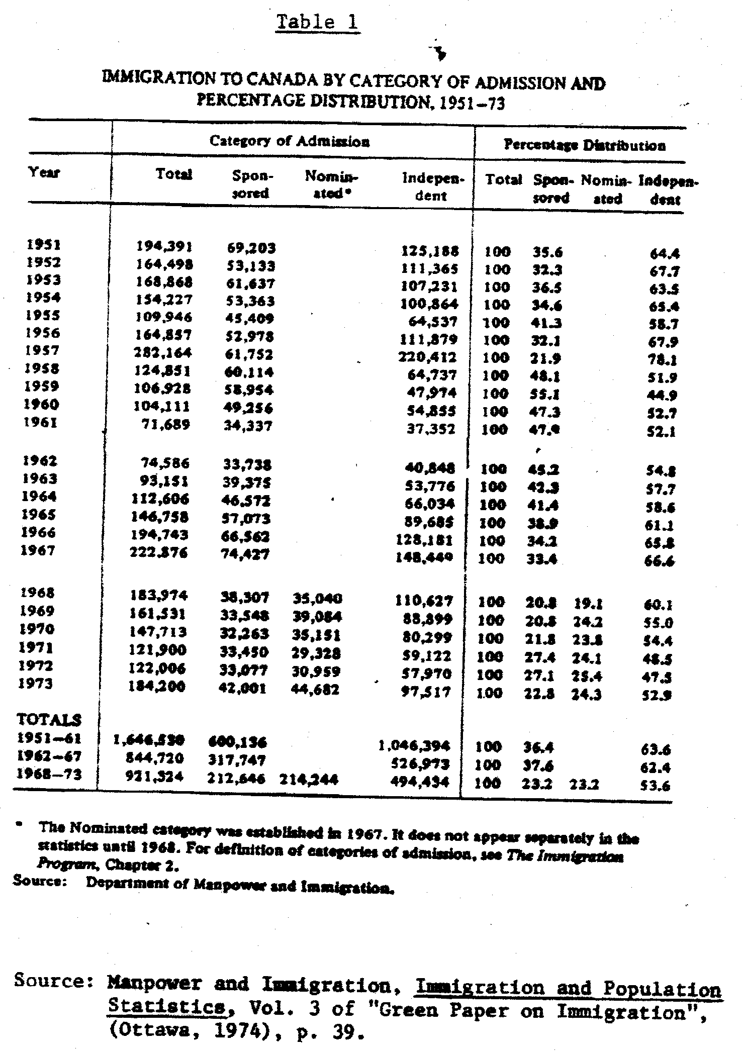
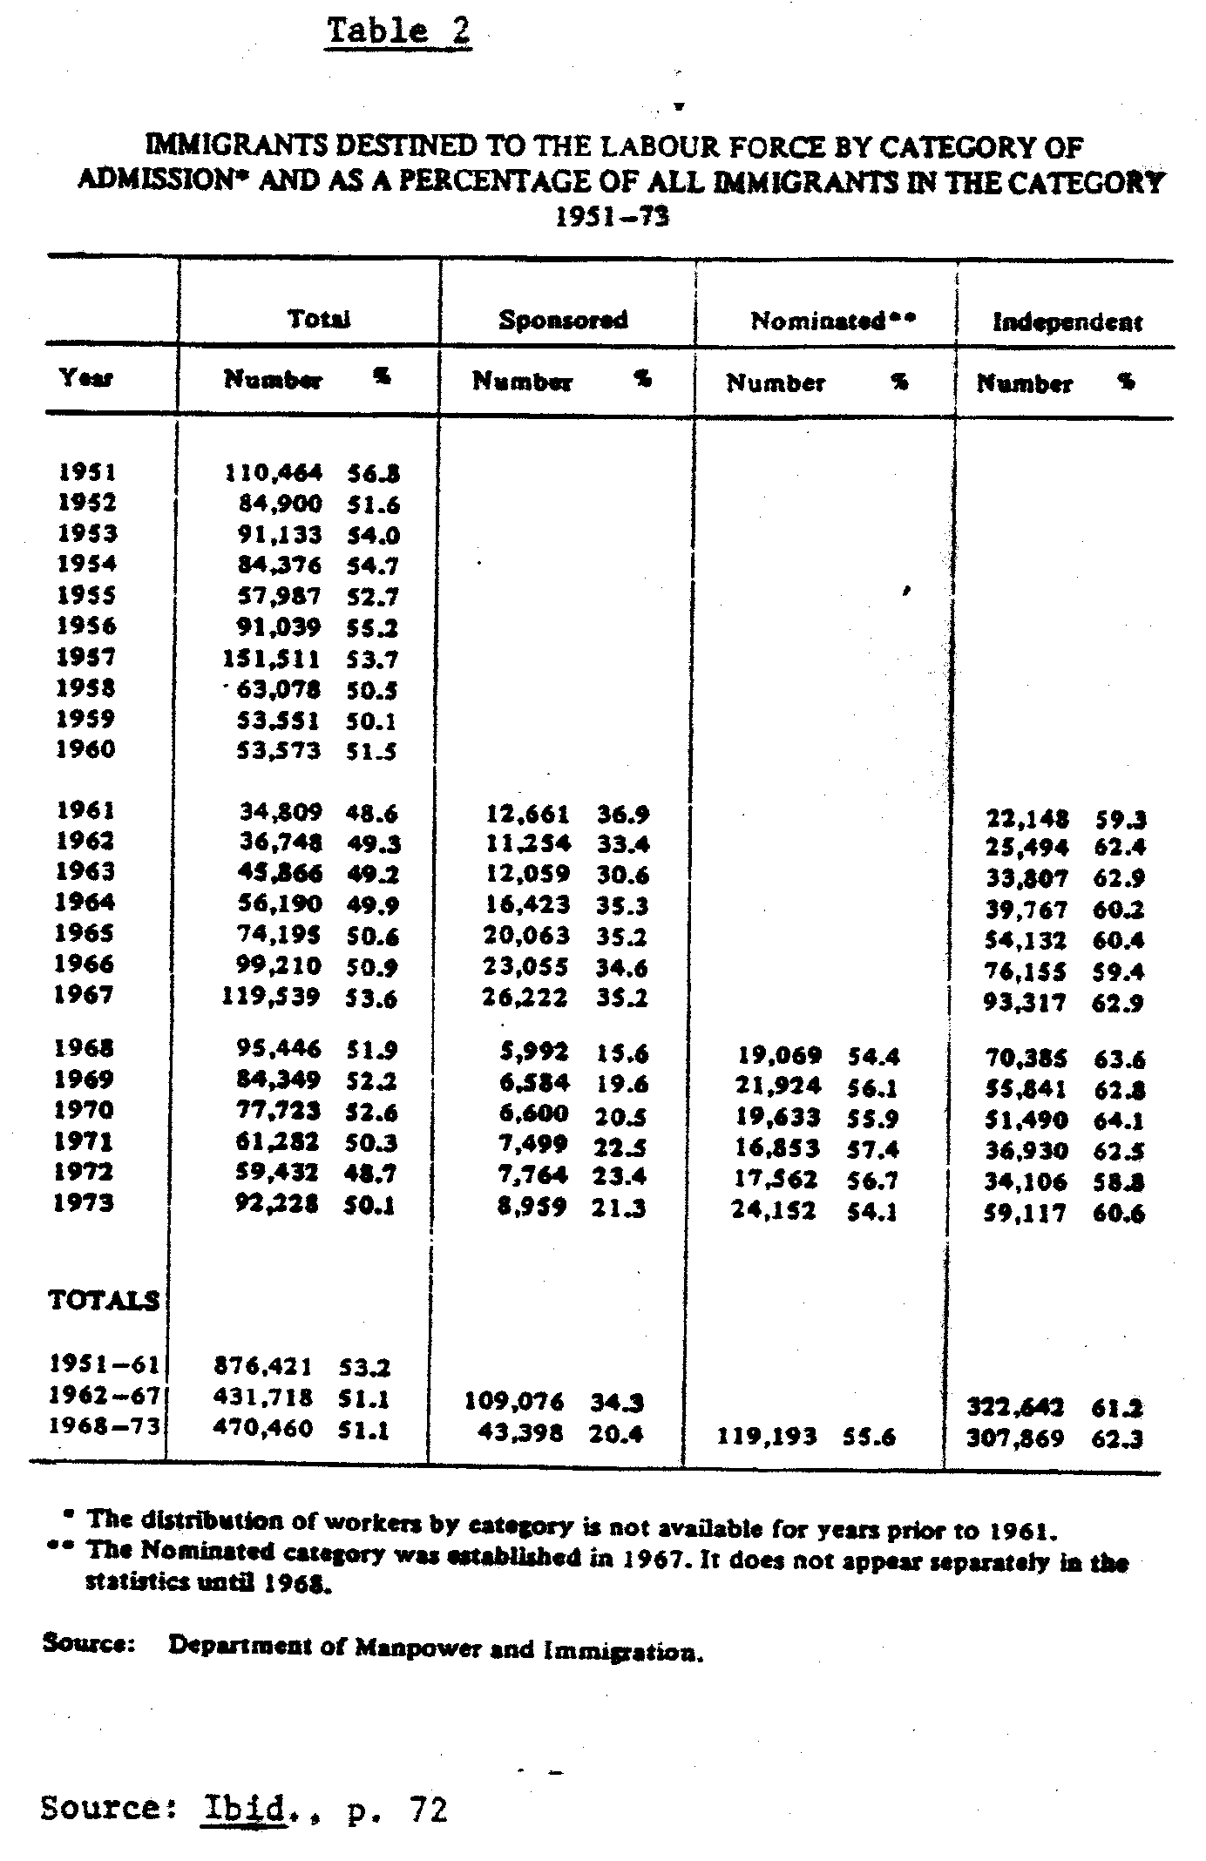
Secondly, with regard to countries which had been traditional suppliers of unskilled labor, the switch from sponsored to nominated immigrants meant that increasingly workers who qualified as nominated immigrants meant that those who qualified as nominated were those who already had some occupational experience, in most cases acquired in the industrial centers of Western Europe, or those who had some technical diploma which increasingly had been acquired in a highly politicized schooling environment.

Italian immigration to Canada provides an interesting illustration of this phenomenon of the circulation of class struggle. The eruption of the Italian student movement from 1967 on, and of the well-known cycle of workers’ struggles from 1968 on, affected Italian immigrant communities in Canada by injecting into them a new élan of militancy.

In some cases newly arrived students and industrial workers, as well as older immigrants influenced by the new Italian political developments, produced an interesting new amalgam which played a central role in the organizing experiences taking place among Italian immigrants in Canada. In the two major areas of Italian immigrant concentration, i.e., Montreal and Toronto, this new social and political amalgam acted as a catalyst for struggles which involved wider sectors of the immigrant community.

But perhaps it was with the West Indian immigration that this aspect of circulating struggle has been most clearly operative. Opening the door to West Indian immigrants meant for Canada gaining access to a labor force which met quite well the new labor market criteria of selection: above average education, mastery of the English language – elements allowing a rapid absorption in the labor market. But it also meant a labor force coming from a highly politicized environment, whether they came directly from the West Indian countries, or from Great Britain – where they had experienced of struggle and practical organization.

To this one must also add the atmosphere of militancy in Black America of the 1960s which inevitably infuenced West Indian students in Canadian universities. The Sir George William University (Montreal) affair of 1969 – when black students occupied the computer center and ultimately smashed it – might have passed as one of the innumerable examples in North American in North American universities, where black students were fighting against racial discrimination in education, except that the event took on immediately an international dimension, operating squarely within the new terrain provided by immigration. A few days after the students involved were charged with “crimes” calling for imprisonment and deportation, massive demonstrations took place in Trinidad against Canadian financial institutions. Soon this wave of protest, and the issue it was confronting, acted as a catalyst setting off a wider process of political confrontations against the Trinidadian State and its specific role in the imperialist control of the working class, culminating in the near-overthrow of the Eric Williams regime (March 1970). The political crises which subsequently spread into several other Caribbean islands cannot be divorced from the material links produced by the immigration process; the successive flows of Caribbean immigrants to Canada were bringing along a more keen political sense of the international framework within which, as immigrant labor, they were moving and selling their labor power.

It is in this context that must be viewed the so-called outbreak of racism during 1973/74 particularly in the Toronto area; but what is important to point out is not so much the campaigns of harassment against blacks conducted by a small local Nazi organization, but rather the way in which the Canadian media seized upon these events and built a case for national racism. However, behind the climate of cultural folklore which surrounded the affair, there was the new reality of a black Caribbean working class coming to Canada fresh from political and organizational experiences, showing itself unwilling to be subjected to a second-class treatment, and which did not lose any time in organizing itself to claim the same rights and treatment enjoyed by Canadian workers and to gain access to practically all occupational levels.

This sector of the immigrant working class which was expected to occupy the lowest rank in the socio-economic hierarchy in Canada had succeeded in contesting one of the fundamental assumptions concerning the pattern of immigrants’ settlement and integration. In so doing it was playing a role of vanguard, especially as this process was occurring at a time when the mobilization of other sectors of the immigrant working class had become increasingly visible.

In other cases, this international dimension was taking other forms – perhaps more indirect – of politicization: Greek immigrants after the 1967 military coup in Greece set up organizations to rally support against the Greek junta; so too did Haitians and later Chileans in response to crackdowns in those countries. In all these cases the mobilizations were taking the form of ongoing denunciation of the Canadian government for its support of the military regimes, but in the process they were giving rise to community organizations concerned with the plight of their immigrant members in Canada.

Obviously, there are important differences in the particular histories and compositions of all these immigrant communities which cannot be analyzed here; but their activities have been a visible expression of the new emerging international climate fed by the new immigration network; and the wave of immigrant militancy and organizational experiences of the late 1960s and 1970s in Canada a central dimension of the international circulation of class struggle.

One direct effect of this new climate – if not one of its main components – has been the increasingly visible mobilization of immigrants around work related demands and issues, and for a greater access to the gammut of social services provided by the state.

In assessing the political significance of this process, one has to be careful not to assume uncritically criteria and codifications which are traditionally employed to analyse “workers” struggles and to measure the level of “class consciousness”. Not only because beyond the traditionally codified event, e.g., the strike or the mass demonstration, there may be a network of socialized behavior (often organized) which is every bit as defiant; but also because the work situation characterizing most immigrant workers is an extremely repressive one – with all the typical corollary of low wages, piece-work, small and highly competitive enterprises and sub-contracting – that explains the low level of unionization and the traditional unions’ unwillingness to venture into this risky, potentially explosive and costly area of organizing.

Because of this strikes in predominantly immigrant workplaces have been fewer in number compared to other strikes. But their political significance and impact outweighs the frequency of their occurrence. Often taking place in the heart of the Canadian metropolis, they have attracted widespread attention, making the struggle of immigrant workers highly visible politically and socially. The strike at the Artistic Woodwork Company during the Winter of 1973/74 in Toronto, is one of the best illustrations.

Immigrant workers in this medium sized furniture company were prevented from unionizing by a whole gammut of very familiar company tactics, but their struggle attracted widespread support from other immigrant and concerned groups. For a period of about three months, daily confrontations on the picket lines to prevent scab labor from being brought into the factory led to over 200 arrests and dominated the news in Toronto. The strike showed the tight alliance among the company, the police and the courts, and the use of illegal (or newly arrived) immigrant workers against resident immigrant workers.

There was also the strike at McGill University in downtown Montreal in 1975 where mostly Portuguese and Italian maintenance workers forced the university administration to grant better wages and working conditions. The strike effectively paralyzed the university for several days owing to the nearly total support received from other university employees and teaching staff, but above all, owing to the organizing aid provided by McGill immigrant students (some of whom were sons and daughters of the striking workers). It was the first strike in the history of McGill University – an institution that has always stood as the main symbol of Anglo-Canadian domination of Quebec, and this explains the sense of class unity exhibited by many Quebecois workers in their support of striking immigrant workers.

This changing awareness among wide sectors of the immigrant working class can only be partially deduced from their behavior in job-related situations. Rather it is necessary to look at their changing attitudes vis-a-vis social services and at their awareness of the role of the state as planner of their daily reproduction. For, in the post-war immigration boom the social hierarchy mentioned above was not only concretized in the job market, but also in the entire process of social reproduction. Education is one of the areas where this process was most blatantly evident.

At a time when the Canadian state launched the most dramatic expansion of education in its history, accompanying this with ideological campaigns stressing “equality of opportunity” and the promises that education would hold for Canadian society, children of immigrants were being railroaded into schools and programs which would limit their access to the labor market or would restrict it to low-paying jobs. The so-called “vocational schools” were one of the institutional inventions used to accomplish this.

These schools processed kids – mostly immigrants and Canadian kids from poor working class neighborhoods – who had been channeled there after having been administered test “showing” their insufficient intelligence or their lack of attitude to pursue regular studies. These schools – one of the many symbols of the prosperity and modernizations of the 1960s – were in fact becoming a new form of ghetto, reproducing at the educational level the divisions and the social hierarchy existing at the broader social level. The struggle that large sectors of the immigrant communities undertook in the late 1960s against the system (especially in Toronto where the issue became more explosive) revealed not only the frustration that had been building up among “new Canadian” kids while they had been processed “democratically” and “scientifically” toward a lower-status future (life), but also the refusal of immigrant parents to allow their children to be subjected to a treatment similar to that which the parents had been forced to undergo out of desperation years before.

Events at St. Leonard, Montreal, in 1968/69 also brought out into the open the frustrations especially of Italian immigrant parents, but in a more dramatic way than in Toronto, and in a much more complex socio-political setting. Their refusal to allow their children to be forced into French-speaking schools (an issue which has continued to be a pain in the ass for both Liberal and Partie Quebecois governments) has been viewed by many Leftist observers as “reactionary” because running counter to the aspirations of the nationalist movement in Quebec. Their refusal, however, has a more direct and immediate class significance, denoting first and foremost their unwillingness to be the object of policies (based on their ethnicity) restricting their access to the labor market, or pre-determining their labor market destination.

Workmen compensation is another area where immigrants have shown their unwillingness to be subjected to discrimination on the basis of their assumed passivity or ignorance of bureaucratic procedures. The leading expression of this has been the creation in 1973 of the Union of Injured Workers grouping mostly immigrant construction workers of the Toronto region. This step was the result of painstaking research and investigation conducted by ethnic community organizers, showing the shameful way in which case after case were either disqualified, ignored or granted lower compensation by the Workman Compensation Board. When in the Spring of 1974 several hundred injured workers – some of them with casts or on cruches – marched downtown in Toronto and then held a rally in front of the Ontario Parliament Building, government security personnel did not pay much attention to it. After all, the day before senior citizens had held their own rally demanding a raise on their pensions. The injured workers would just enrich the demonstration carrousel adding color to the folklore of Ontario politics. But it must have come as a surprise when the demonstrators forced their way through the weakly guarded entrance, invaded the building, interrupted the session of parliament, and thus forced the politicians to listen in person to their demands. For most of them this was the closest they had come to seeing ordinary immigrants face to face – and they did take a good look at them under the light of TV reflectors. For the mobilization continued in the following weeks and months, becoming one of the central issues of Ontario politics, and leading to major revisions in workmen compensation procedures.

It would be a major mistake of political evaluation to view developments such as this as just an example of thewider phenomenon of pressure-group politics. For, when coupled with other similar demands coming from immigrant communities in recent times, the whole reflects a qualitative change in the immigrants’ perception of their role and value as labor power in the broader social context, and of the State as planner and organizer of their daily life. And it is this perception that can explain their increasing demand for a social wage – whether in the form of adequate workmen compensation, unemployment insurance benefits, welfare, payments for youth projects or mothers allowances. Petitions circulated by the Wages for Housework organization against government freezing of family benefits showed that the great majority of immigrant women approached to sign the petition saw mother allowances as a form of the social wage – however small – for their work as housewives. The much published campaign by the Canadian government against alleged abusers of unemployment insurance was most often directed against “new Canadians” – both because it was easier to disqualify them through tricky questions, and because it was felt they would respond more easily to government intimidations. But it also showed that immigrant workers had learned to make use en masse of this form of social wage in ways that matched their Canadian counterparts. And the same thing can be said of the ability increasingly shown by “new Canadian” youth to obtain government funds for various types of community projects as a way to gain access to the wage by bypassing the “narrow gateway” of the labor market.

This increasing awareness among immigrants of their right to some form of social wage, and their willingness to fight for it, is therefore something that goes beyond the seeming pressure-politics aspect that their actions have often taken, and represents one of the main elements in the process of class recomposition that has taken place in Canada during the last decade or so. It is also one of the main factors beneath the current crisis of the labor market in Canada.

However, this process cannot be understood as long as “labor market” is viewed as synonymous with “waged-job market”, and as long as the cycle of capitalist production is viewed as separate from the cycle of social reproduction. It must be said – perhaps painfully – that this dichotomy of perspective has been a problem that only the Left had had. Capital has always seen the two cycles as being inseparable one from the other. After all, it is on this crucial consideration that immigration as a capitalist policy has historically been based. By importing labor power ready to be cycled and recycled into the process of accumulation the collective capitalist of the receiving country has avoided the social cost of raising and training this labor power. Moreover, by adopting policies (as Canada has done) excluding or limiting immigrant access to government social services, much of the burden of social reproduction falls squarely on the immigrants and their families, and again the collective capitalist saves enormously on the social costs necessary for the reproduction of that labor power. It must be re-emphasized, therefore, that the social and economic hierarchy that capital has imposed on its national and immigrant working classes is not a hierarchy of ethnic cultures (as the Canadian policy of “multiculturalism” has led many to believe). Rather it is a hierarchy which has been structured both in the “job-market” and in the process of social reproduction, i.e., in the access to social services necessary for such reproduction. Immigrant women, on whose unpaid domestic labor and on whose underpaid waged-labor much of the reproduction of immigrant labor has rested, know this very well.

Therefore, the demand for social wages is an attempt to valorize the labor necessary to social reproduction; its political significance stems from the effect it is having in stalling the mechanisms of hierarchy in the cycle of social reproduction, thus striking at one of the central points of the capitalist use of immigration. Its most immediately visible effect has been the growing refusal by “new Canadians” of the capitalist tyranny of the “job market”; their unwillingness to submit themselves to the constraints (material and ideological) of the “job market” as the only way to gain access to the means of daily life.

But when one considers the degree of government control over these payments as well as their monetary levels, one might argue that the refusal of the “job-market” in favor of some form of social wage goes in the direction of capitalist policy and represents a further step in the process of proletarization typical of the present international crisis. Yet, this process loses any politically negative connotation once it becomes a new terrain for unifying collective behavior based on the immigrants’ awareness of their role in the cycle of capitalist production and reproduction; once they begin to prefigure a new class rationality in contraposition to the dominant rationality and legitimation; once they see themselves as confronting not the juridical state as dispenser of public justice, but the capitalist State as planner of accumulation and proletarization; once they force the collective capitalist to enlarge the sphere of exchange value from the factory and the “job market” to the wider sphere of social reproduction.

It is very important at this point in time to raise the question to what extent the increasing immigrants’ demand to valorize labor necessary to social reproduction is creating a new political terrain characterized by a thrust toward autonomous socialization. This is where the need for analysis is most urgent: tracing the process of transition of the immigrant ghetto as socialization of survival to the immigrant ghetto as socialization based on the autonomous imposition of new needs.

What for now has become quite evident is that behind the problem of urban congestion decried by the government and associated with the settlement patterns of immigrants there is the refusal of geographical mobility; there is the immigrants’ social and political choice of territory – a choice which opposes to the planned dynamism of the labor market a growing class rigidity limiting this dynamism and transforming it into a political problem. Herein lies an important dimension of the “crisis of the labor market”. The attempt through the White Paper to rationalize the labor market by resorting to measures of economic planning have proved insufficient, and call for measures blatantly political in nature in order to impose coercion.

III

Too little time has passed since the implementation of the new immigration law for us to be able to analyze in detail how the dynamics of the labor market and the composition of the working class have been influenced by these new restrictive measures.

Further, the progressive deterioration of the Canadian economy and the vicissitudes of federal policy during the last two years seem to have temporarily shifted immigration problems to a lower priority. This makes it difficult to sort out the coherence of government strategy.

Yet, judging from several imporant cases of government action, several interpretive hypotheses seem plausible. We can ask ourselves, for example, if the recent agreement between Ottawa and Quebec – an agreement which gives the Quebec government greater independence in the selection of potential immigrants for this Province – reflects a tendency toward an operational decentralization which could have important reprocussions on regional labor markets.

Similarly, we can ask ourselves if the recent rescue operation of thousands of Indochinese refugees is part of an established tactic of large scale recruitment of immigrants considered ideologically “sure” and ready to be sent toward regions and localities by the government.

Moreover, as some observers have underlined, the new measures can have the effect of discouraging applicants by presenting them with legal entry conditions they would find too severe. This would, at the same time, encourage an inflow of illegal immigrants outside the legal requirements for entry.

In other words, only a deeper analysis will reveal to what degree the new regulations will result in an adequate influx of immigrant manpower without producing a need for new “special programs” and without creating a new problem of illegal immigration.

What seems evident – as this article has tried to show – is the anti-worker character of these new immigration measures, and the fact that they are intended to break a cycle of class recomposition during which immigration became an increasingly important terrain of resistance against capitalist planning.

In Canada – as in most countries – the history of immigration (and of emigration) is inseparable from the history of the power relations between classes. The 1970s illustrate very clearly this class dynamic and also show to what degree the attack on the immigration front is only one element of a vaster strategy against the working class of Canada. It is not by historical coincidence that the elaboration of a new immigration policy occurred at the same moment that the State launched its repressive action against wage struggles (through the legal control of wages and the repeated use of special legislation forcing a return to work of striking workers) and undertook systematic reductions in the area of social expenditures – worsening the conditions of social reproduction of large sectors of the working class.

Today, while economic and social policies – as well as generalized unemployment – create an expanded dependence on waged work, the labor market has once more become the privileged instrument for capital to discipline the attitudes and expectations of the working class (Canadian or immigrant) and to impose a higher social productivity.

Rarely has the need for unity among different sectors of the working class been felt so acutely.

(Montréal, 1980)

* * *

Bibliographical Notes and Acknowledgments

An earlier version of this article appeared as “Crisi del capitale e la nuova politica emigratoria” in Immigrazione e Communita Italiana nel Quebec, 1978.

The fundamental work on the evolution of Canadian immigration policy in the period to the end of the 1960s is that of Freda Hawkins, Canada and Immigration, Montreal, London, 1972 [Second edition, 1988]. On the economic aspects of post-war immigration, see the complete and up-to-date work of Alan Green, Immigration and Post-war Canadian Immigration Policy, Toronto, 1976.

The concept of political recomposition of the class is elaborated in Zerowork #1 (1975) and #2 (1977).

There are many governmental publications on this subject, but two documents were particularly helpful for this study: Ministry of Manpower and Immigration, Canadian Immigration Policy, 1966, White Paper on Immigration, Ottaway 1966 and Etude sur l’immigration et les objectifs demographiques du Canada, also known as the Green Paper on Immigration, Ottaway, 1974, 4 volumes.

For this study the author has mainly drawn on press reports and on interviews. We should note the exceptional importance of the Montreal paper Il Lavoratore (which ceased publication in 1975).

The author would like to express his appreciation to the following persons who helped him with information and discussion of various points raised in the article: Franklin Harvey of Canadian Dialogue, R.A. Kozlowski of Problem Central (Toronto), Denis Amadou of the Association of Greek Workers (Montreal), Sergio La Verghetta who shared his very useful thesis with me: “L’immigrazione italiana nel Canada,” (University of Padova, 1975) and the members of the Collectivo Emigrazione di Montreal. I especially appreciate the time given to useful comments on the first draft of this article by Michel Del Balzo.

